|  |  |
| --- | --- |
| **Ex. No : 1**  **Date :** | **Install Virtualbox/VMware Workstation** |

**AIM:**

Find procedure to Install Virtualbox/VMware Workstation with different flavours of linux or windows OS on top of windows7 or 8.

This experiment is to be performed through portal.

**PROCEDURE :**

Step 1- Download Link

Link for downloading the software is [https://www.vmware.com/products/workstation-pro/workstation-](https://www.vmware.com/products/workstation-pro/workstation-pro-evaluation.html) [pro-evaluation.html](https://www.vmware.com/products/workstation-pro/workstation-pro-evaluation.html). Download the software for windows. Good thing is that there is no signup process. Click and download begins. Software is around 541 MB.

Step 2- Download the installer file

It should probably be in the download folder by default, if you have not changed the settings in your browser. File name should be something like [VMware-workstation-full-15.5.1-15018445.exe](https://www.vmware.com/go/getworkstation-win). This file name can change depending on the version of the software currently available for download. But for now, till the next version is available, they will all be VMware Workstation 15 Pro.

Step 3- Locate the downloaded installer file

For demonstration purpose, I have placed the downloaded installer on my desktop. Find the installer on your system and double click to launch the application.

Step 4- User Access Control (UAC) Warning

Step 5- VMware Workstation Setup wizard

Now you will see VMware Workstation setup wizard dialog box. Click next to continue.

Step 6- End User Licence Agreement

This time you should see End User Licence Agreement dialog box. Check “I accept the terms in the Licence Agreement” box and press next to continue.

Step 7- Custom Setup options

Select the folder in which you would like to install the application. There is no harm in leaving the defaults as it is. Also select Enhanced Keyboard Driver check box.

Step 8- User Experience Settings

Next you are asked to select “Check for Updates” and “Help improve VMware Workstation Pro”. Do as

you wish. I normally leave it to defaults that is unchecked.

Step 9- Application Shortcuts preference

Next step is to select the place you want the shortcut icons to be placed on your system to launch the application. Please select both the options, desktop and start menu and click next.

Step 10- Installation begins

Step 11- Launch VMware Workstation

After the installation completes, you should see VMware Workstation icon on the desktop. Double click on it to launch the application.

Step 12- Licence Key

If you see the dialog box asking for licence key, click on trial or enter the licence key. Then what you have is the VMware Workstation 15 Pro running on your windows 10 desktop. If don’t have the licence.

Step 13- At some point if you decide to buy

At some point of time if you decide to buy the Licence key, you can enter the Licence key by going to **Help->Enter** **a** **Licence** **Key** You can enter the 25 character licence key in the dialog box shown below and click OK. Now you have the licence version of the software.

**OUTPUT:**

Step 1:

Download the VMware from their official website.

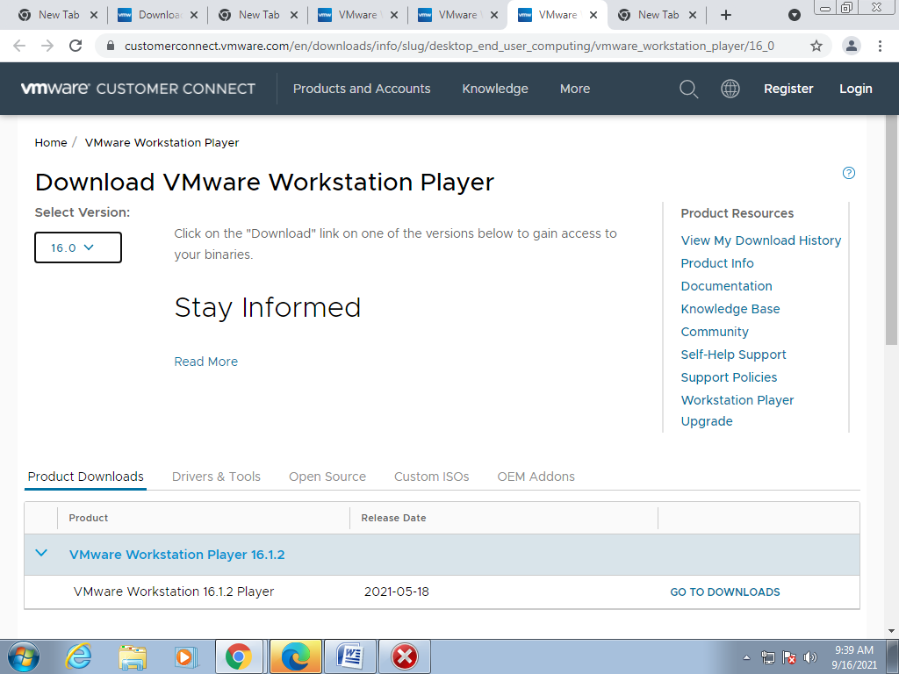

Step 2:

Select the desired version.(here it is 14.0)

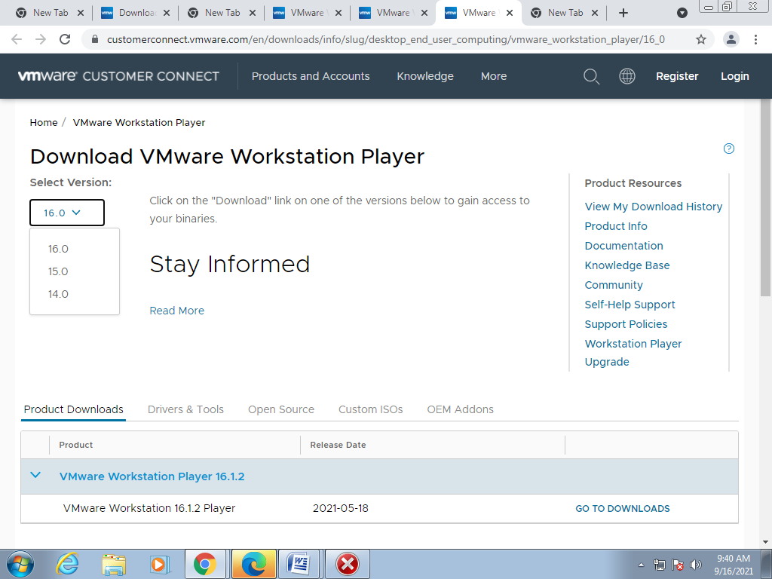

Step 3:

Select the version.

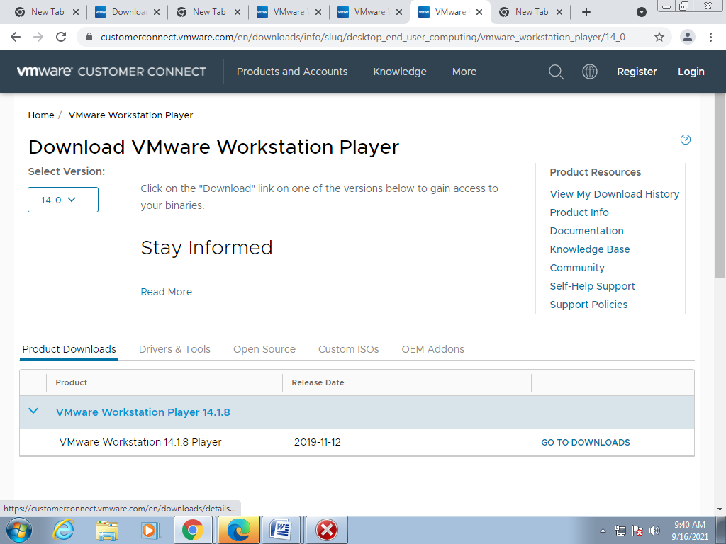

Step 4:

Click Download Now.

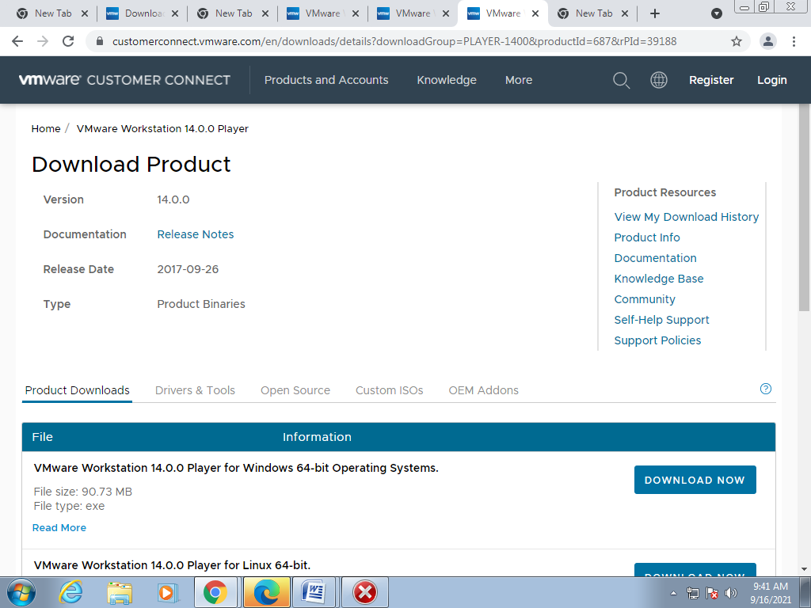

Step 5:

Double Click on the downloaded file. Click Install.

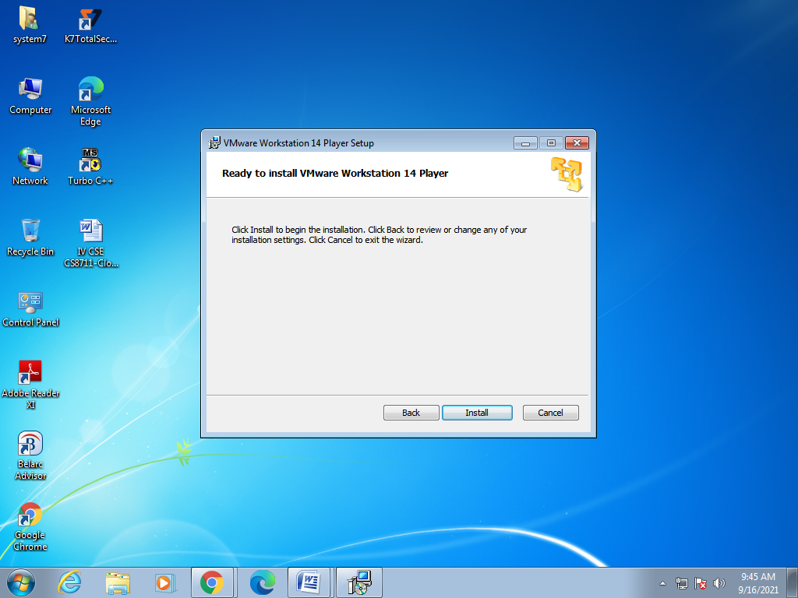

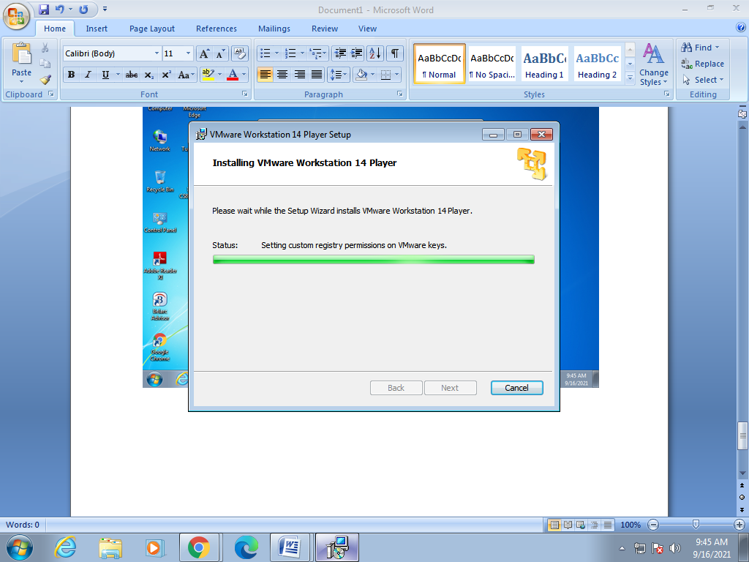

Step 6:

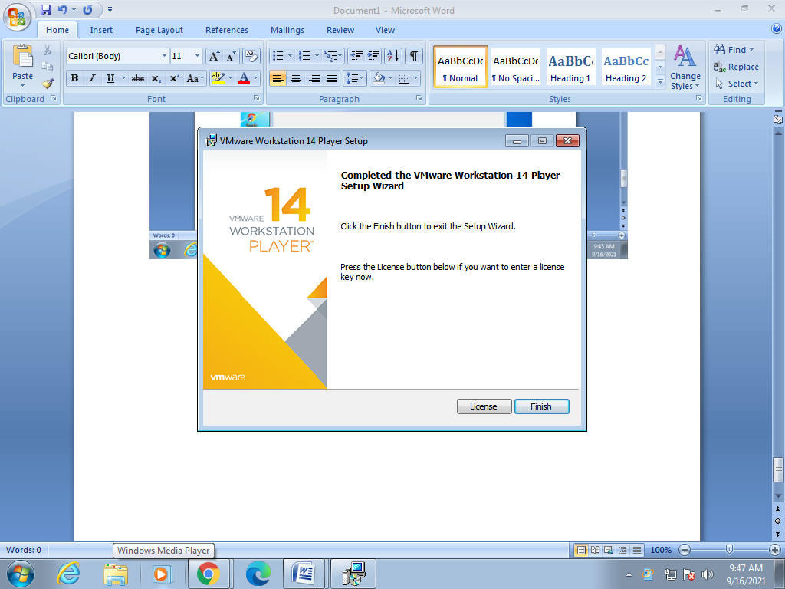 Click Finish.

Step 7:

Select “Use VMware workstation 14 player for free for non-commercial use”. Click Continue.

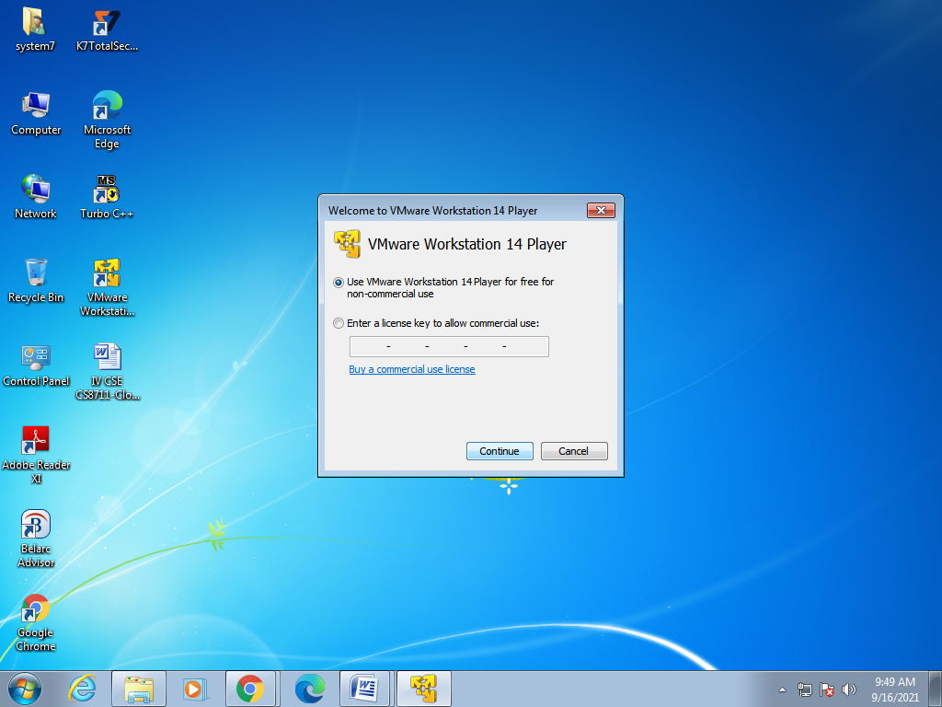

Step 8:

Click Remind Me Later.

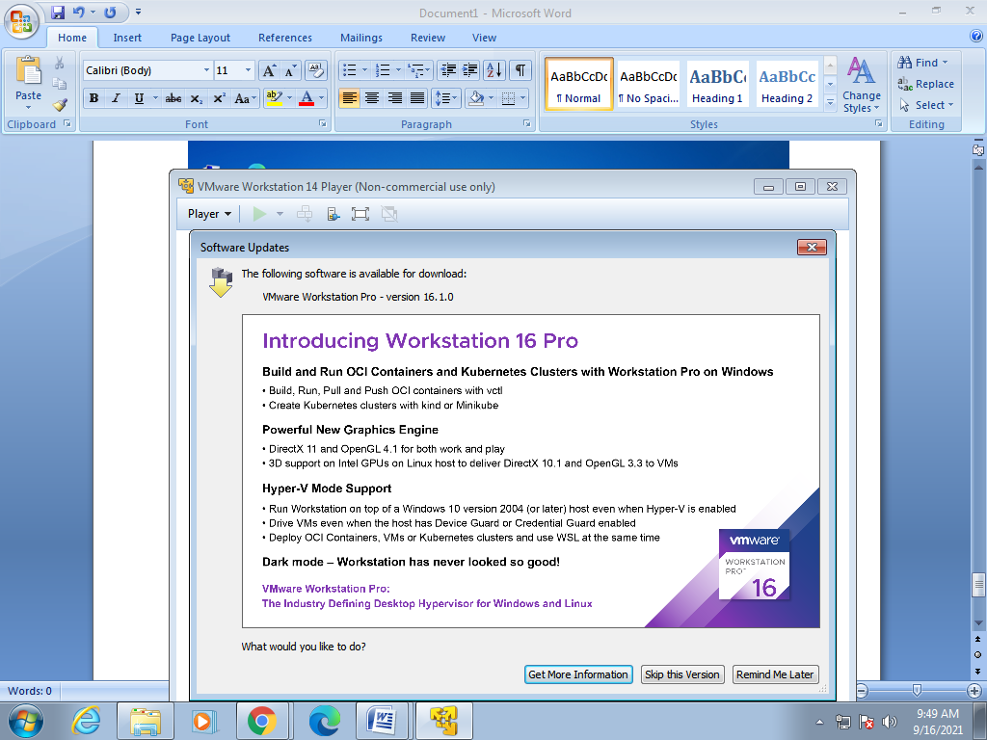

Step 9:

VMware will be launched.

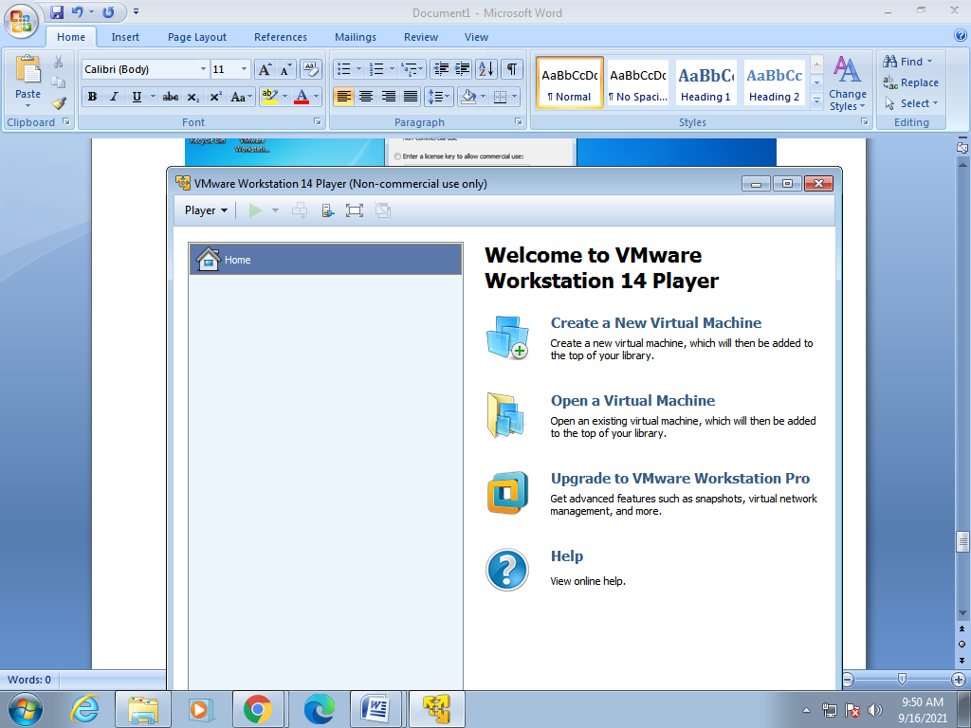

**RESULT :**

Thus the procedure to Install Virtualbox/VMware Workstation with different flavours of linux or windows OS on top of windows7 or 8 is implemented.

|  |  |
| --- | --- |
| **Ex. No : 2**  **Date :** | **Install a C compiler in the virtual machine created using virtual box and execute Simple Programs** |

**AIM :**

To install a C compiler in the virtual machine created using virtual box and execute Simple Programs.

**PROCEDURE :**

**Install VirtualBox :**

1. Visit <http://www.virtualbox.org/wiki/downloads>.
2. Download , Virtual Box platform packages for your OS.
3. Open the Installation Package by double clicking.
4. Click continue and finish installing Virtual Box.
5. When finished close the window.

**Install Linux using Virtual Box :**

1. Run VirtualBox by double-clicking the icon.
2. Click “New” button on the top left corner.
3. Choose the amount of memory to allocate (I suggest choosing between 5I2 MB to I024 MB).
4. Click Continue or Next.
5. Choose create a new virtual hard disk.
6. Click Continue or Next.
7. Choose a VDI.
8. Click Continue or Next.
9. Choose “Dynamically Allocated” click continue.
10. This way, the size of your Virtual Hard Disk will grow as you use.
11. Click the folder icon and choose the ubuntu iso file you downloaded.
12. Select the size of the Virtual Disk (I recommend choosing 8 GB) and click continue.
13. Click create.

**Running Linux :**

1. Choose Ubuntu from left column and click Start and continue.
2. Click the folder icon and choose the ubuntu iso file you
3. Check “Download updates” and click Forward.
4. Choose “Erase disk and install Ubuntu” and click Forward.
5. Click “Install Now” and wait. Maybe grab a snack.When finished, click Restart n and press Enter.

**C Programming on Linux :**

1. Open Terminal (Applications-Accessories-Terminal).
2. Open gedit by typing “gedit &” on terminal.
3. Type the following on gedit:

#include<stdio.h>

Main(){

printf(“hello world”) ;

}

1. Save this file as “helloworld.c”.
2. Type “ls” on Terminal to see all files under current folder.

Confirm that “helloworld.c” is in the current directory. If not, type cd DIRECTORY_PATH to go

to the directory that has “helloworld.c”.

1. Type “gcc helloworld.c” to compile, and type “ls” to confirm that a new executable file “a.out” is created.
2. Type “./a.out” on Terminal to run the program
3. If you see “Hello World” on the next line, you just successfully ran your first C program!
4. Try other codes from “A Shotgun Introduction to C” on professor Edwards’s webpage.You can

also find many C programing guides online.

**OUTPUT :**

**Creating a New Virtual Machine**

Step 1:

Click Create a New Virtual Machine.

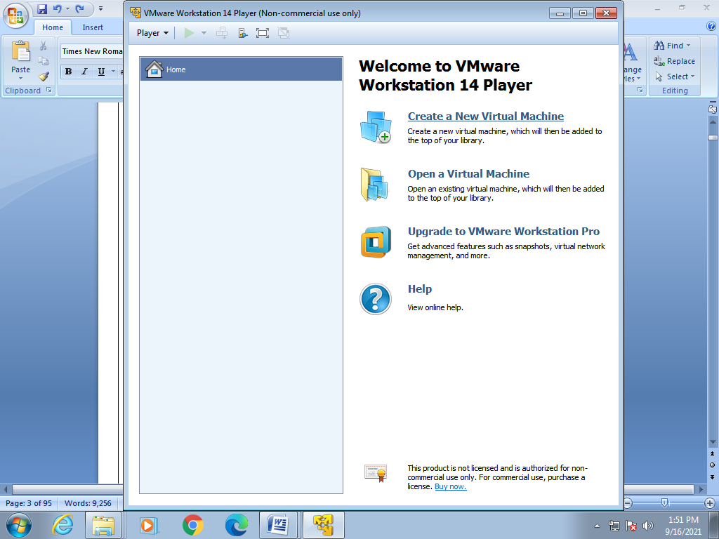

Step 2:

Select the desired Operating System's image file.(here it is Ubuntu)

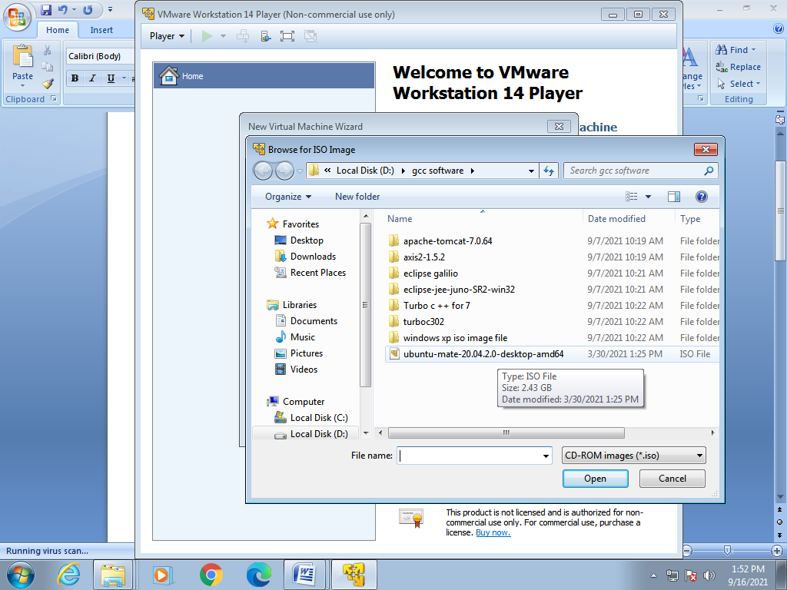

Click Open.

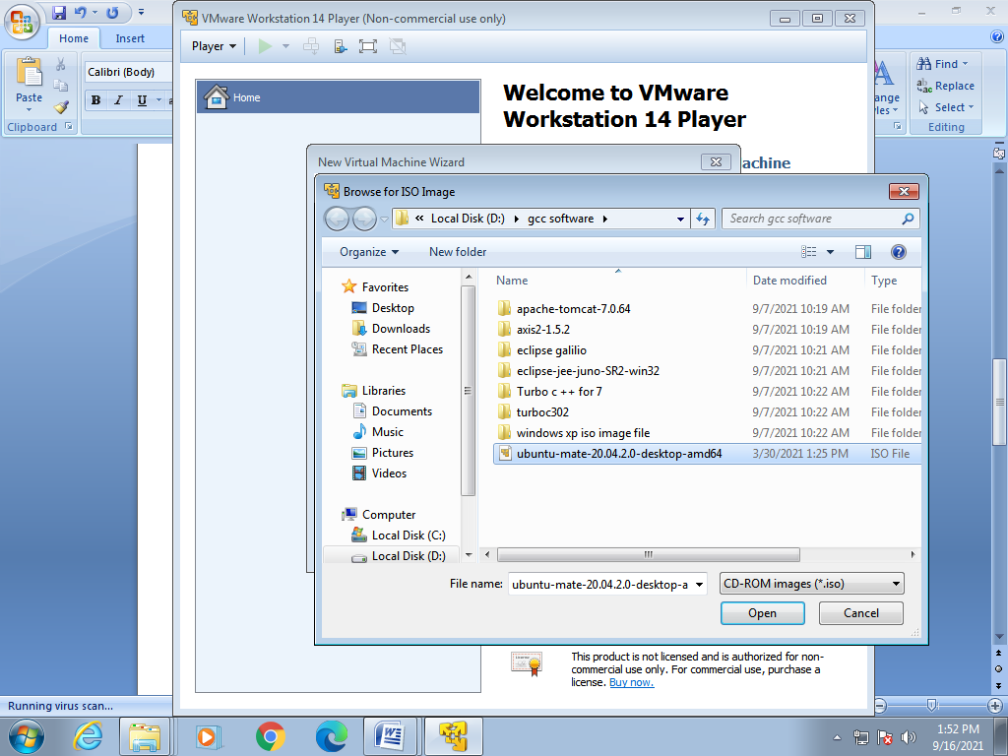

Step 3:

Click Next.

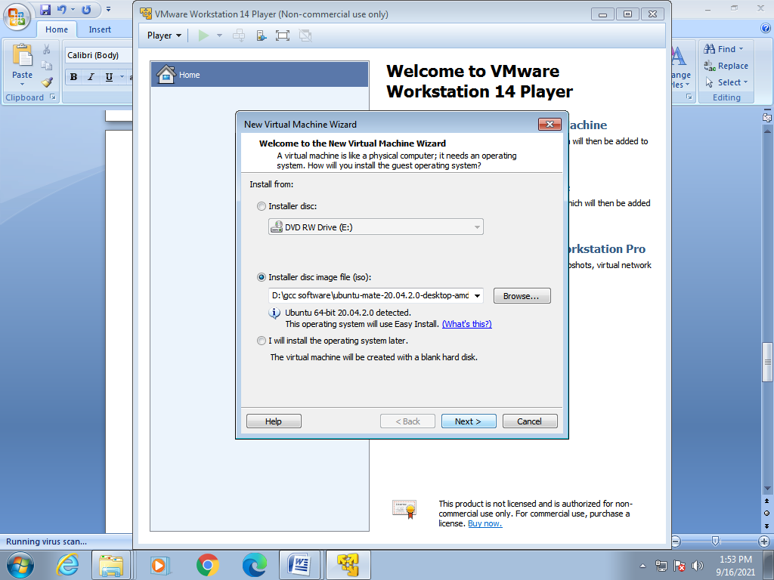

Step 4:

Give your Name, Username and Password. Click Next.

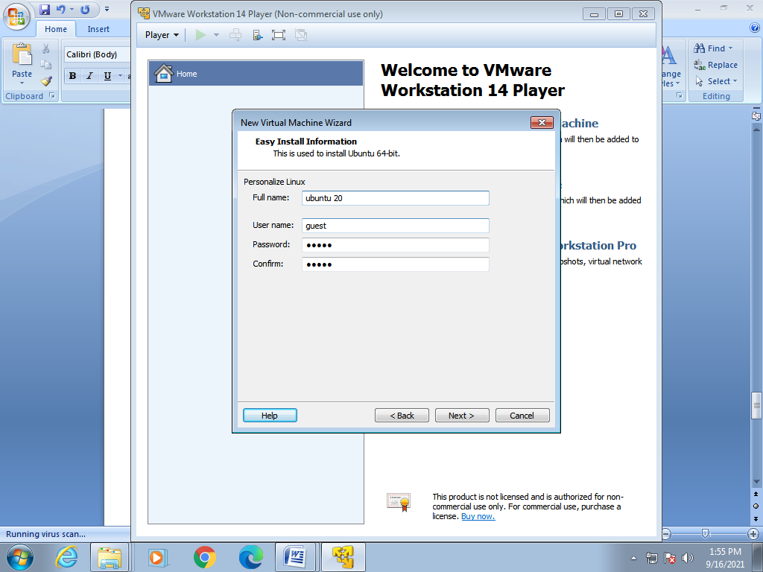

Step 5:

Give your Virtual Machine a Name and select the location. Click Next.

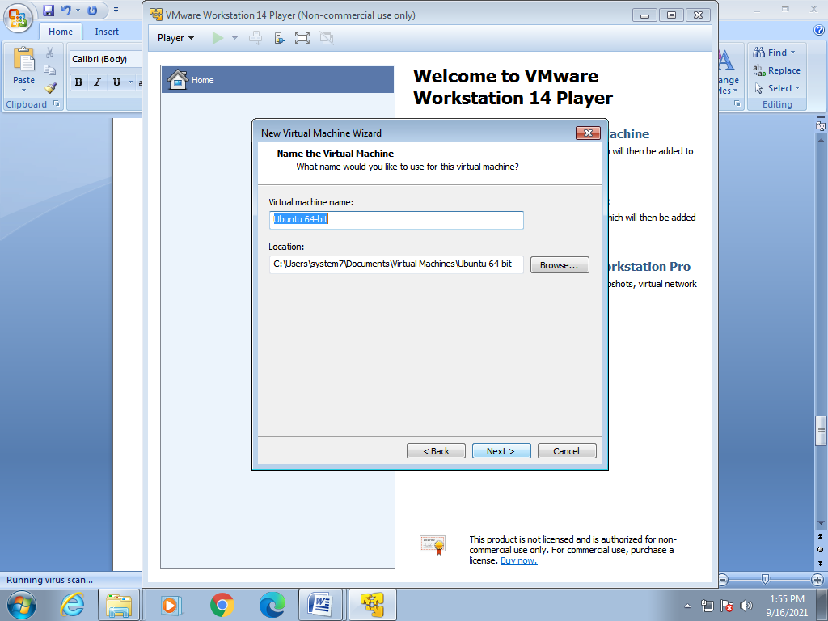

Step 6:

Click Next.

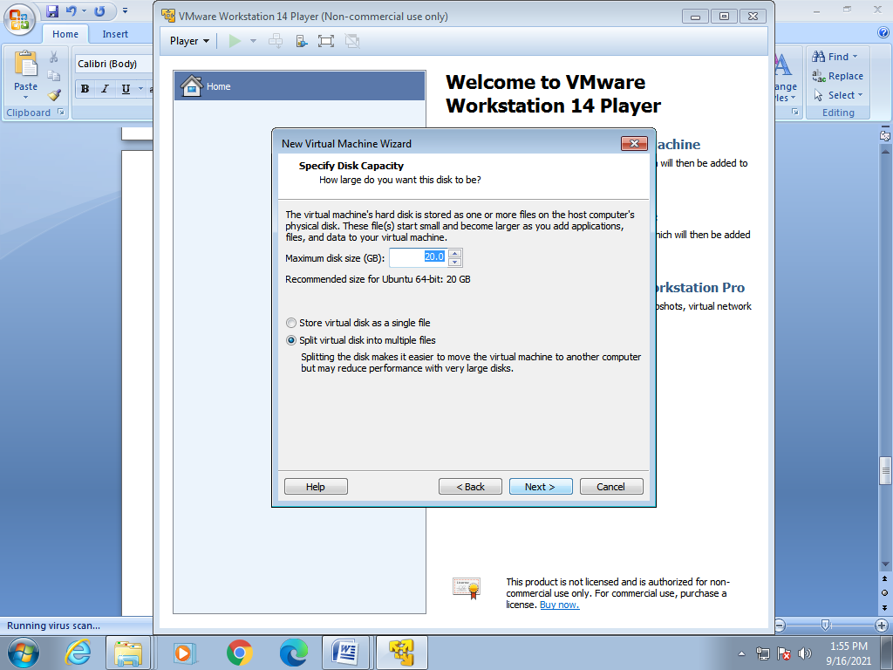

Step 7:

Click Finish.

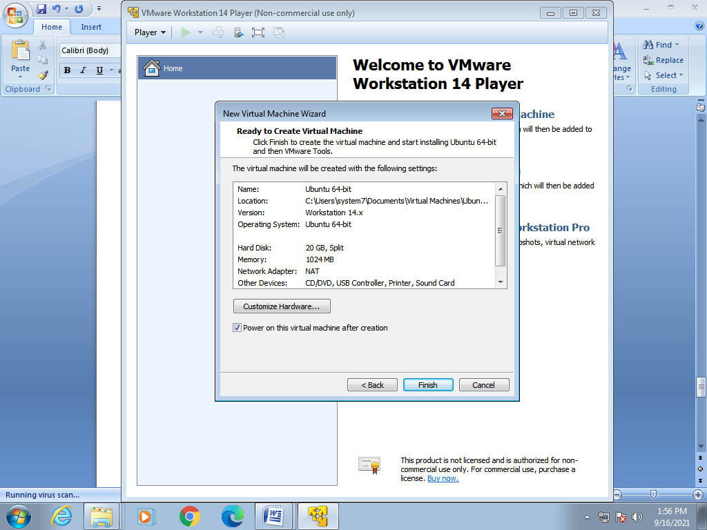

**Running a C Program is Ubuntu**

Step 1:

Launch the Virtual Machine. Right Click on the screen and select Open in Terminal.

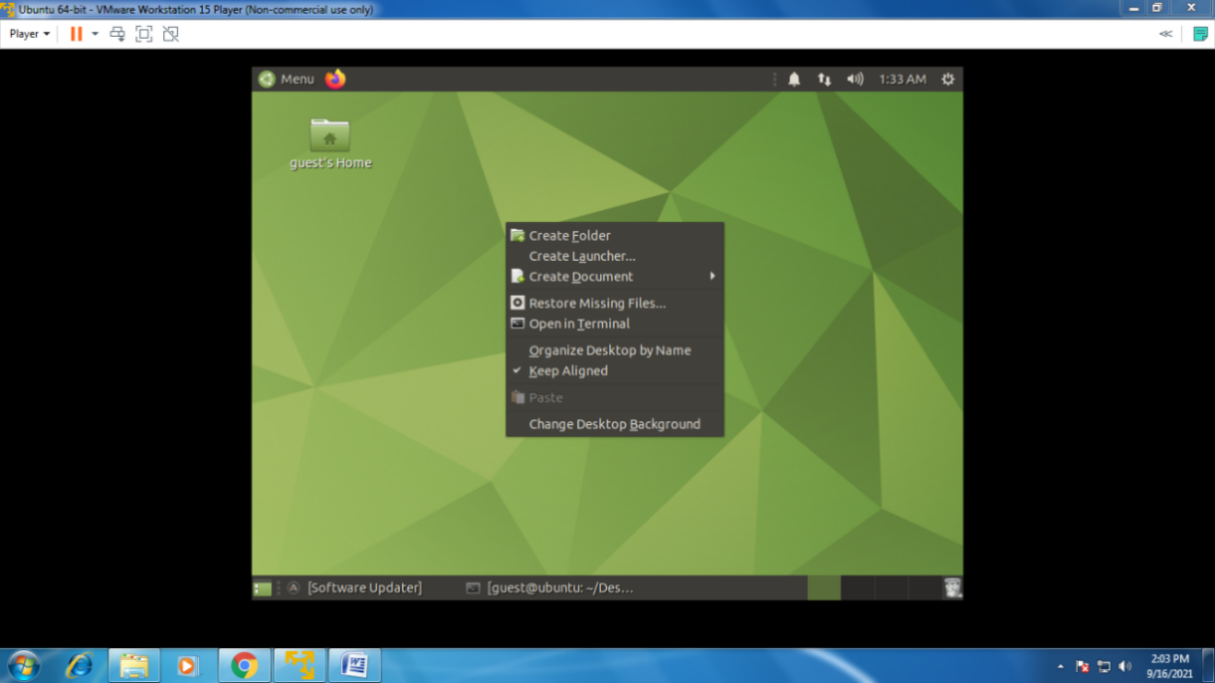

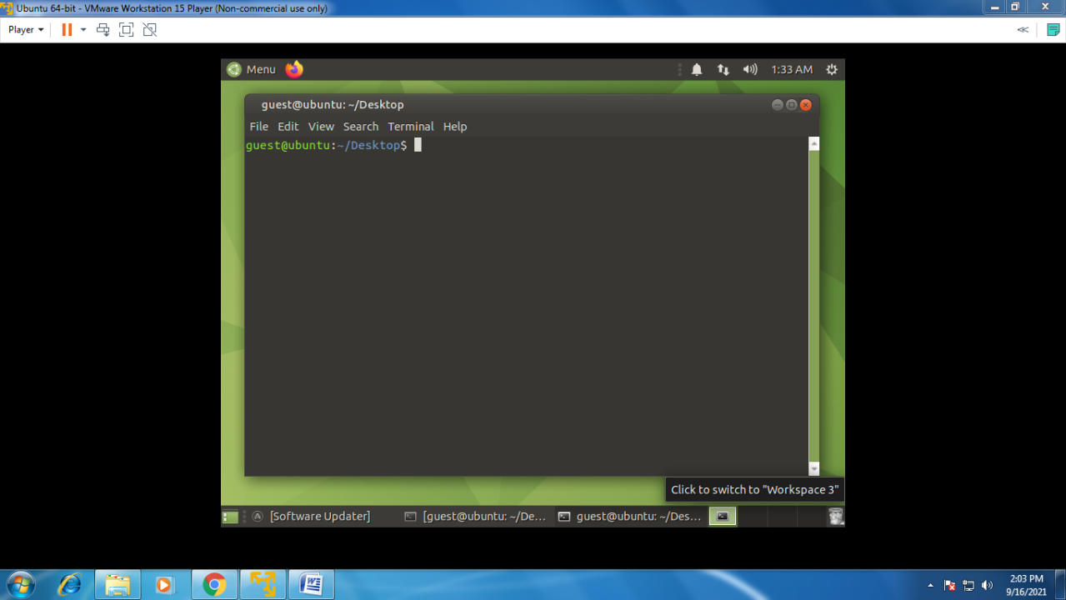

Step 2:

Run the command “” to ensure every Pre-requisite is installed.

Give password if required.

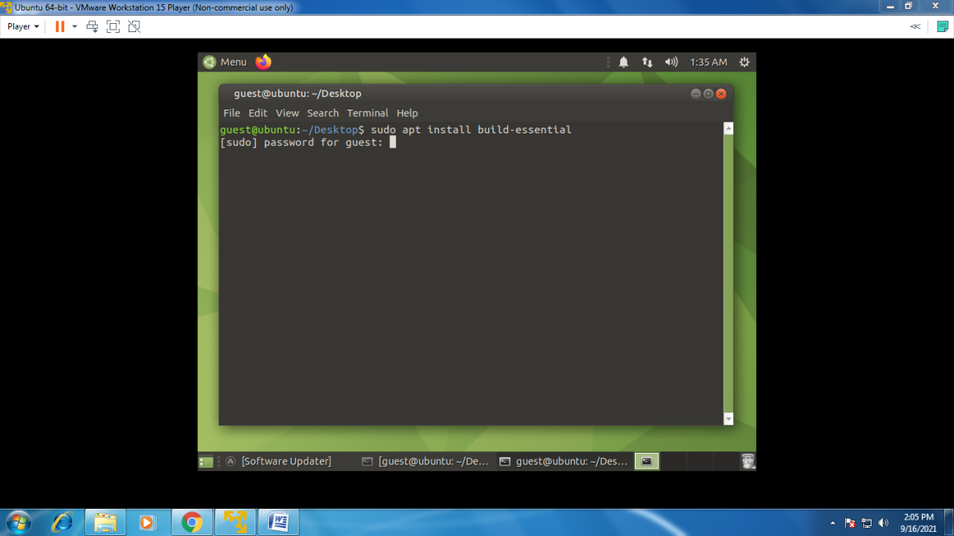

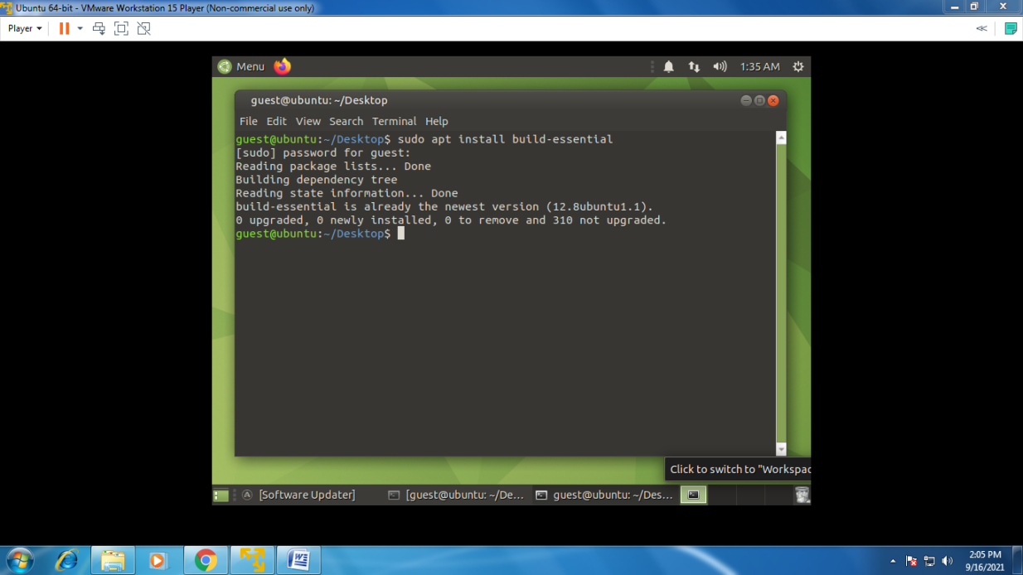

Step 3:

Create a C file using the command “touch hello.c”.

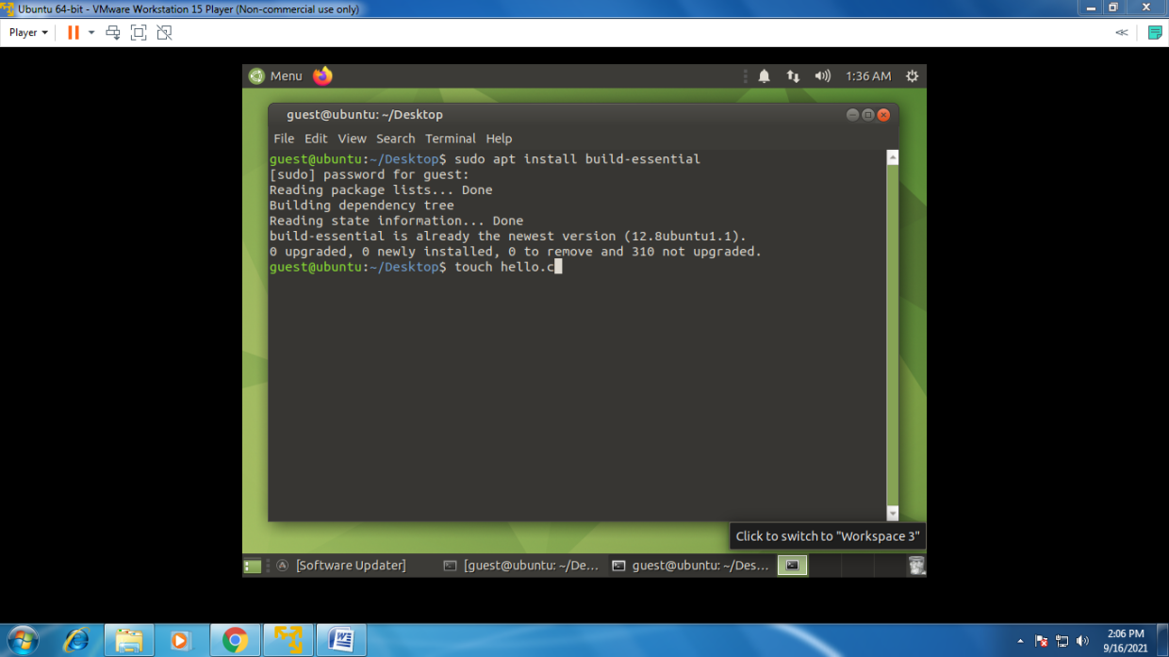

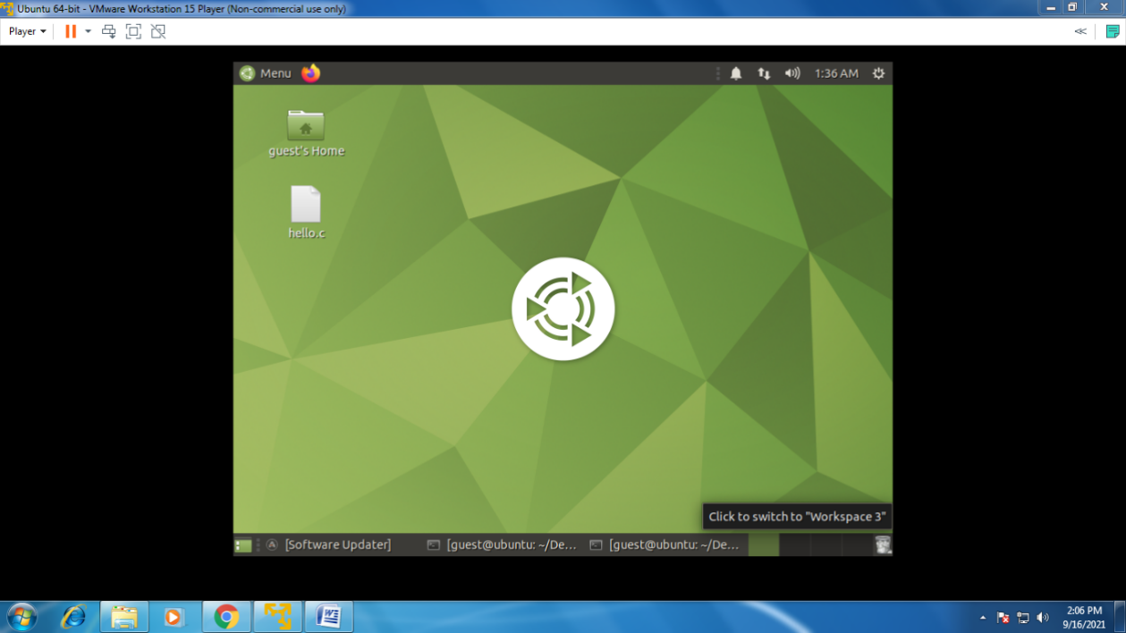

Step 4:

Double Click on the C file. Write an Hello World Program and save it.

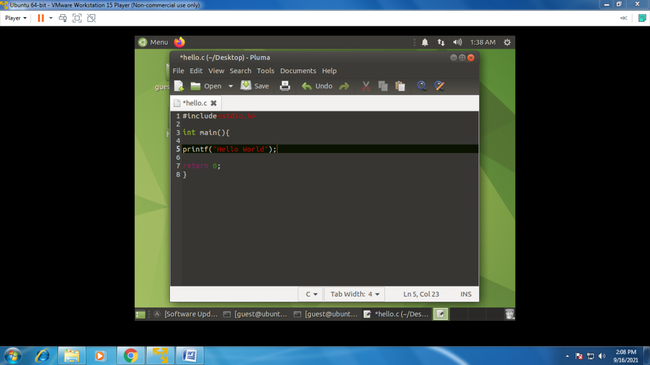

Step 5:

Open the terminal and type this command “gcc hello.c -o test”. This will create a test file.

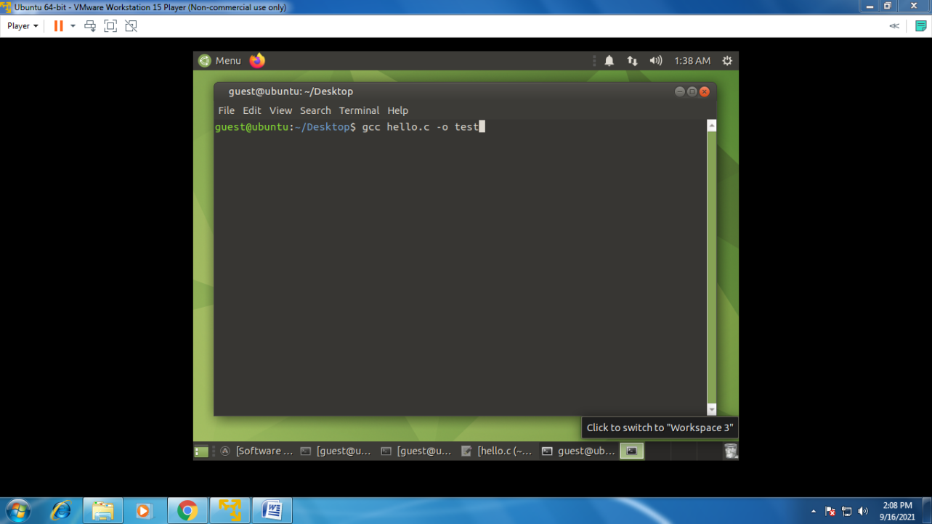

Step 6:

To run the program run this “./test” command in terminal. Output will be displayed.

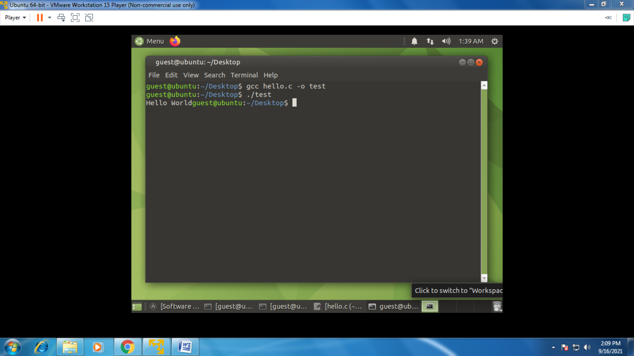

**RESULT :**

Thus a C compiler in the virtual machine created using virtual box is installed and Simple Programs is executed.

|  |  |
| --- | --- |
| **Ex. No : 3**  **Date :** | **Install Google App Engine. Create hello world app and other simple web applications using python/java.** |

**AIM :**

To install Google App Engine. Create hello world app and other simple web applications using python/java.

This document describes the installation of the Google App Engine Software Development Kit (SDK) on a Microsoft Windows and running a simple “hello world” application.The App Engine SDK allows you to run Google App Engine Applications on your local computer. It simulates the run-­‐time environment of the Google App Engine infrastructure.

**PROCEDURE :**

#### Download and Install:

1. You can download the Google App Engine SDK by going

to:<http://code.google.com/appengine/downloads.html> and download the

appropriate install package.

1. Download the Windows installer – the simplest thing is to download

it to you Desktop or another folder that you remember.

1. Double Click on the **GoogleApplicationEngine** installer.
2. Click through the installation wizard, and it should install the App

Engine. If you do not have Python 2.5, it will install Python 2.5.

1. Once the install is complete you can discard the downloaded installer.
2. Make a folder for your Google App Engine applications. I am going to

make the Folder on my Desktop called “**apps**” – the path to this

folder is:

C:\Documents and Settings\csev\Desktop\app

1. And then make a sub-­‐folder in within **apps** called “**ae-­01-­trivial**” – the path

To this folder would be:

#### C:\ Documents a nd Settings \csev\Desktop\apps\ae-­01-­trivial

1. Using a text editor such as JEdit (www.jedit.org), create a file called **app.yaml** in the

**ae-­01-­trivial** folder with the following contents:

application: ae-01-trivial version: 1

runtime:

python api_version: 1

handlers:

url: /.*

script: index.py

1. Then create a file in the **ae-­01-­trivial** folder called **index.py** with three lines in it:

print 'Content-Type: text/plain' print ' '

print 'Hello there Chuck'

**OUTPUT :**

**Python Installation**

Step 1:

Download Python from python.org and install it in your PC.(python 2.5 is used here)

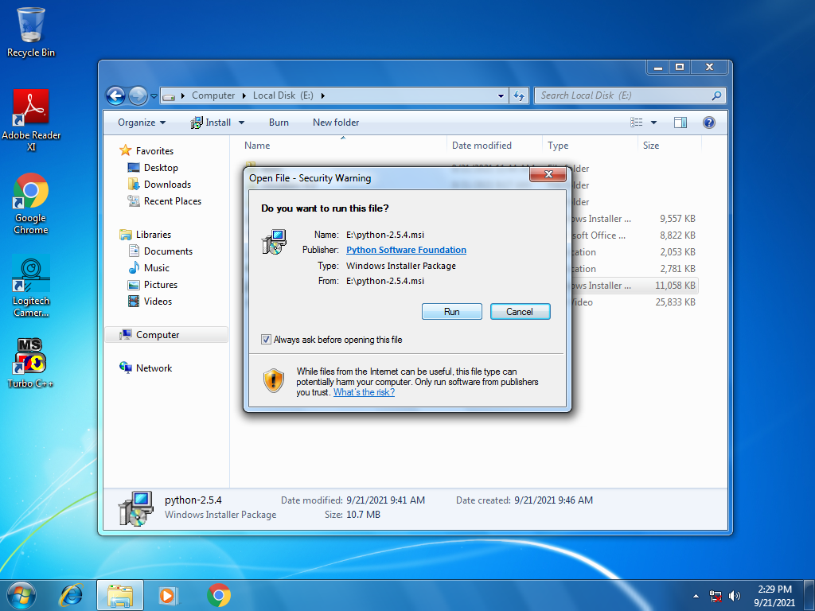

Step 2:

Select “Install to all users” and click Next.

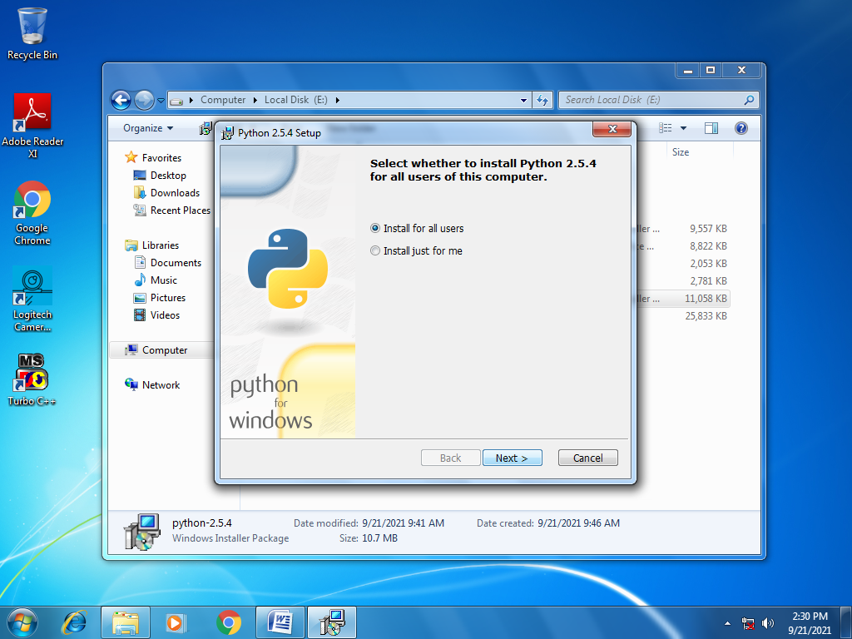

Step 3:

Select the directory for the Python files and click Next.

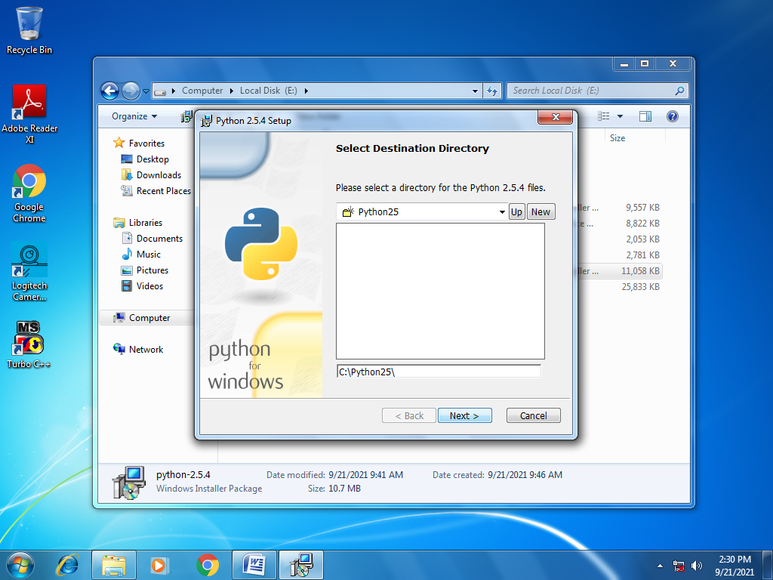

Step 4:

Click Finish.

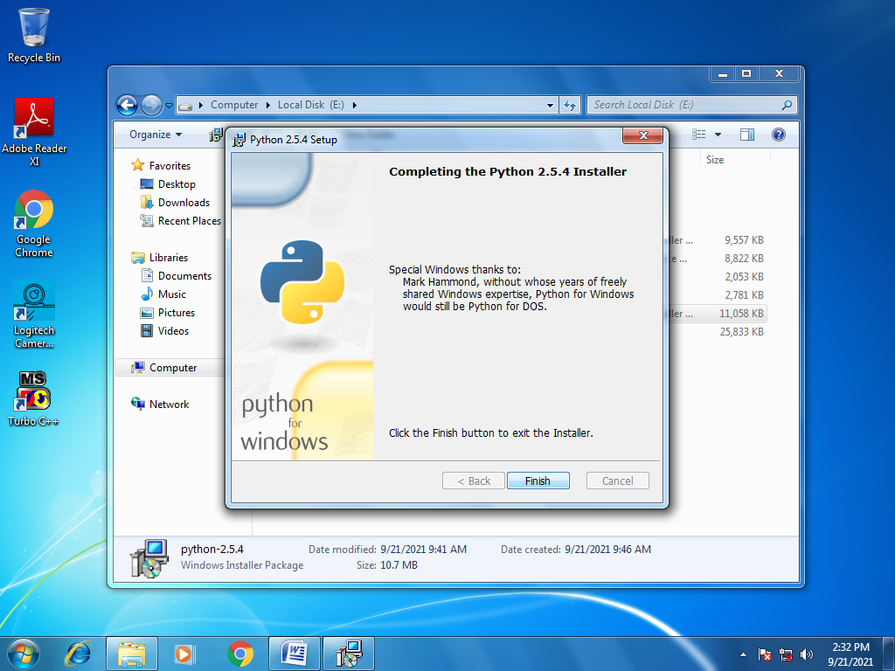

**Google App Engine Installation**

Step 1:

Download and install the Google App Engine.

Please make sure that Python is installed properly in your PC because Python is a Pre-requisite.

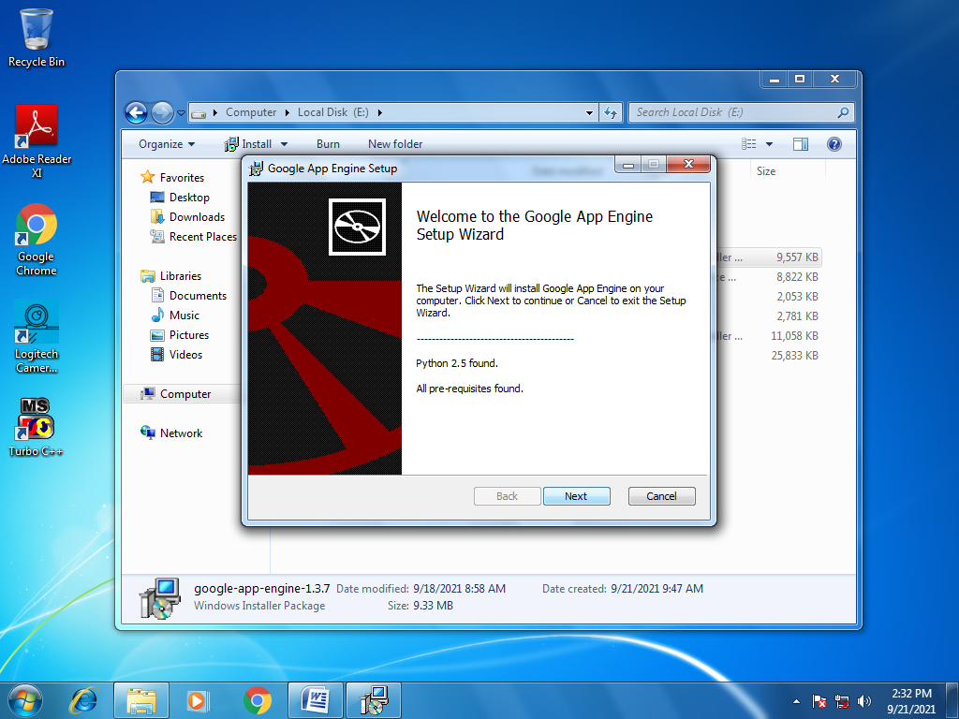

Step 2:

Check “I accept the terms in the License Agreement” and click Next.

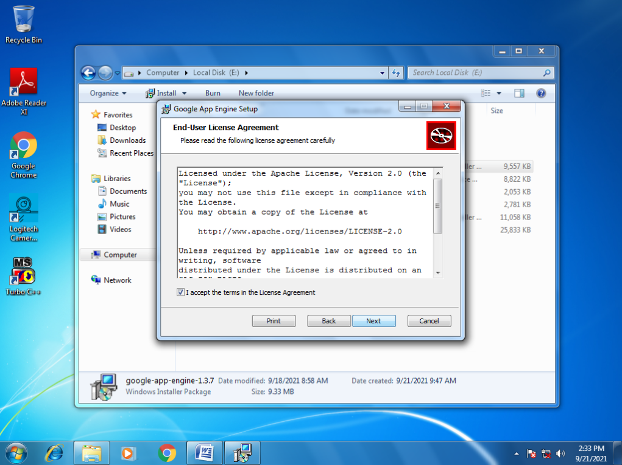

Step 3:

Select the Path and click Next.

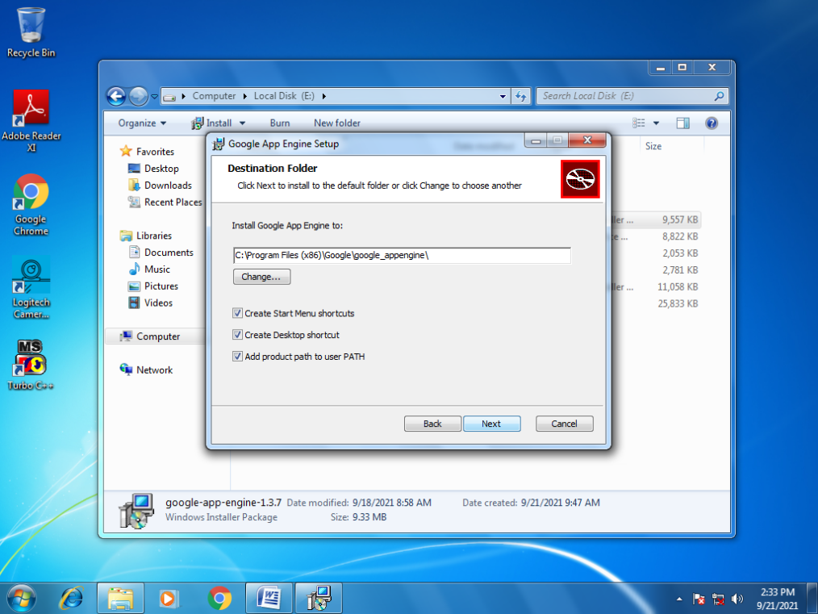

Step 4:

Click Install.

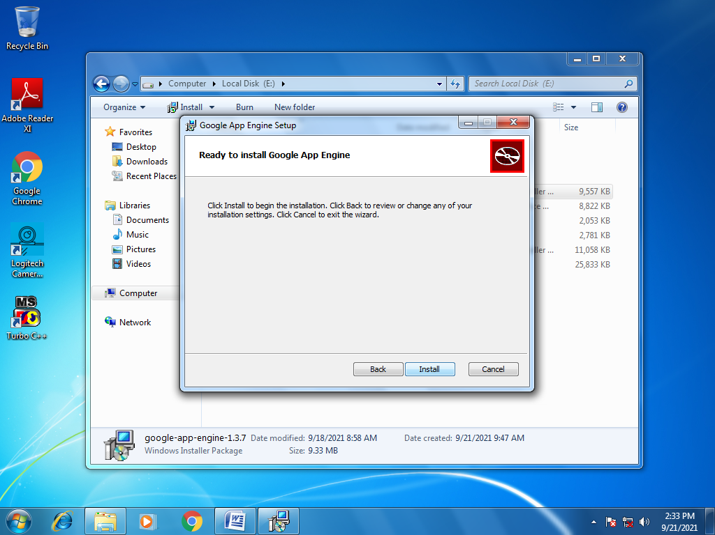

Step 5:

Click Finish.

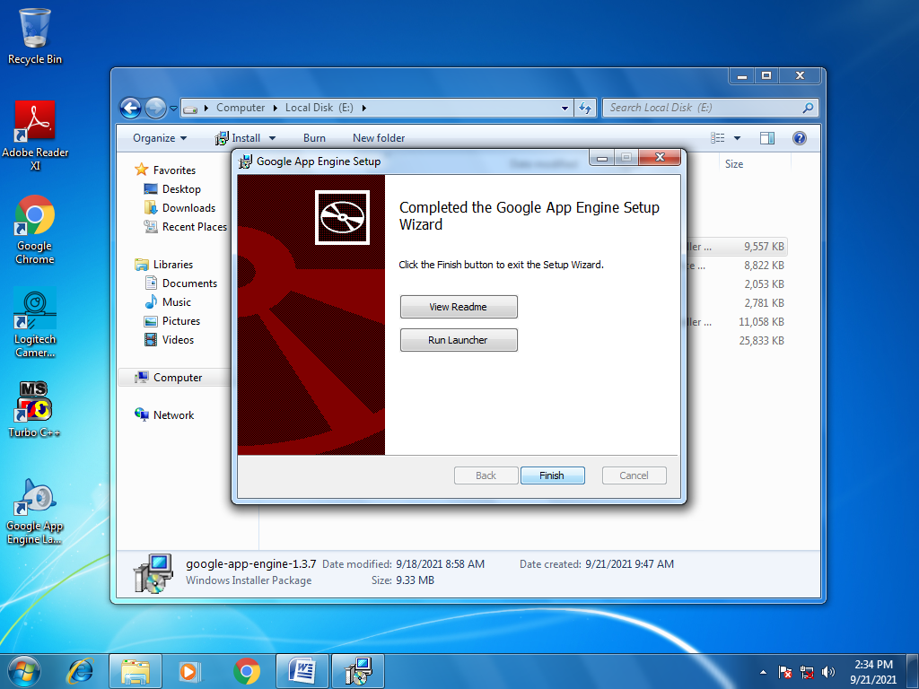

**Notepad++ Installation**

Step 1:

Download and Install Notepad++.

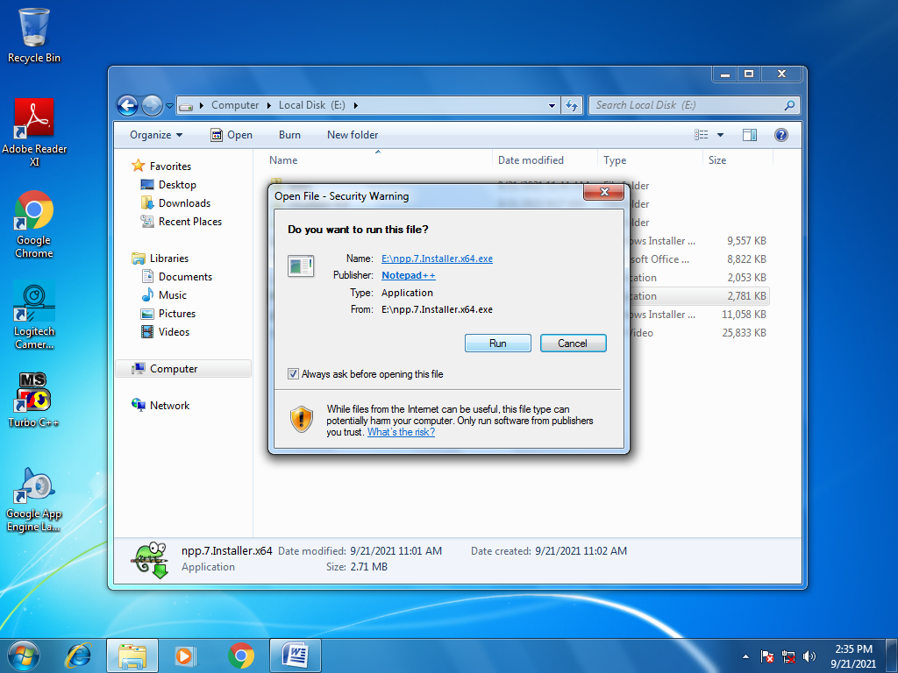

Step 2:

Click Next.

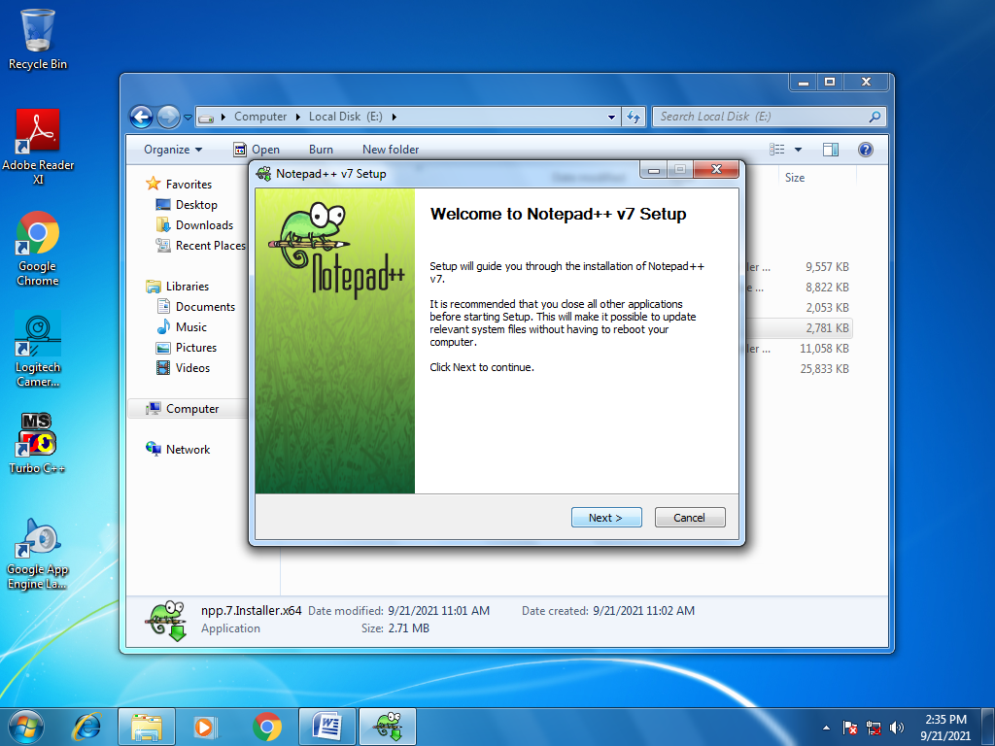

Step 3:

Read the terms and conditions. Click I Agree.

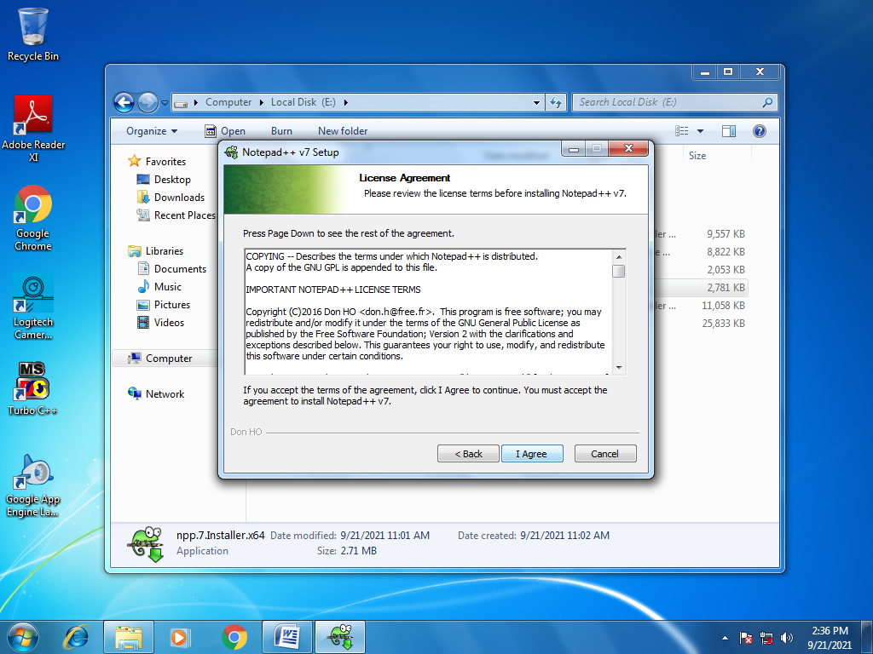

Step 4:

Click Install.

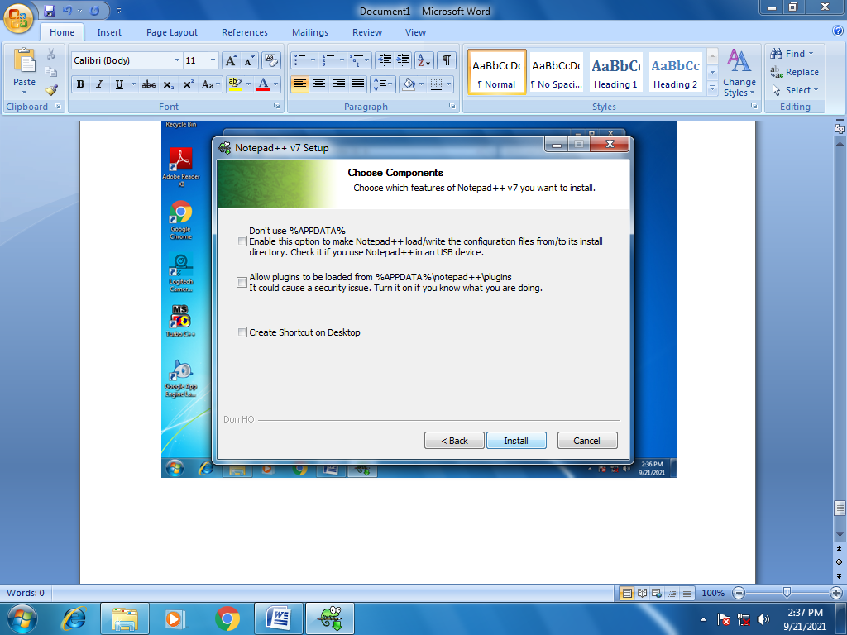

Step 5:

Click Finish.

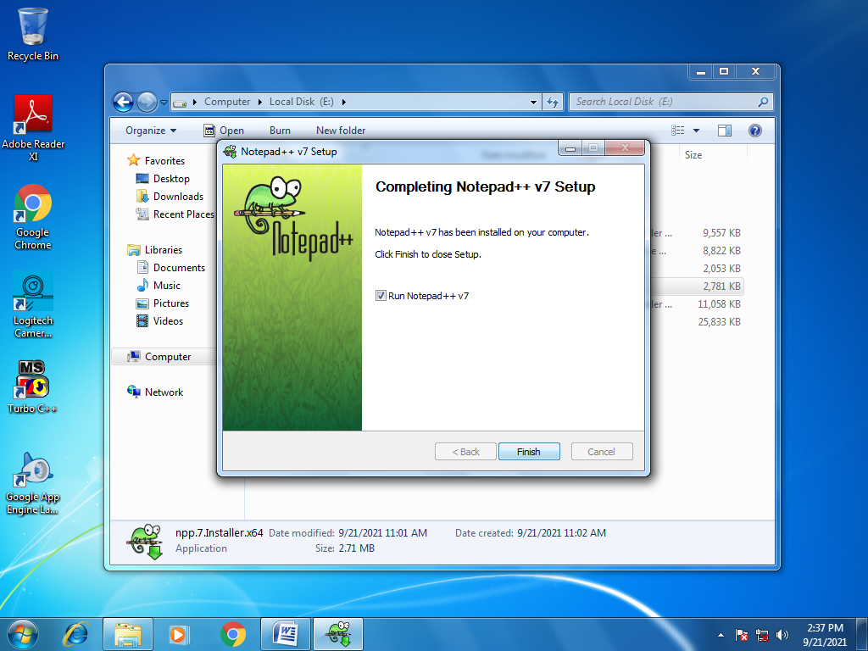

**Running a Python program using Google App Engine**

Step 1:

Open Notepad++ and create hello.py file.

In hello.py write the following code.

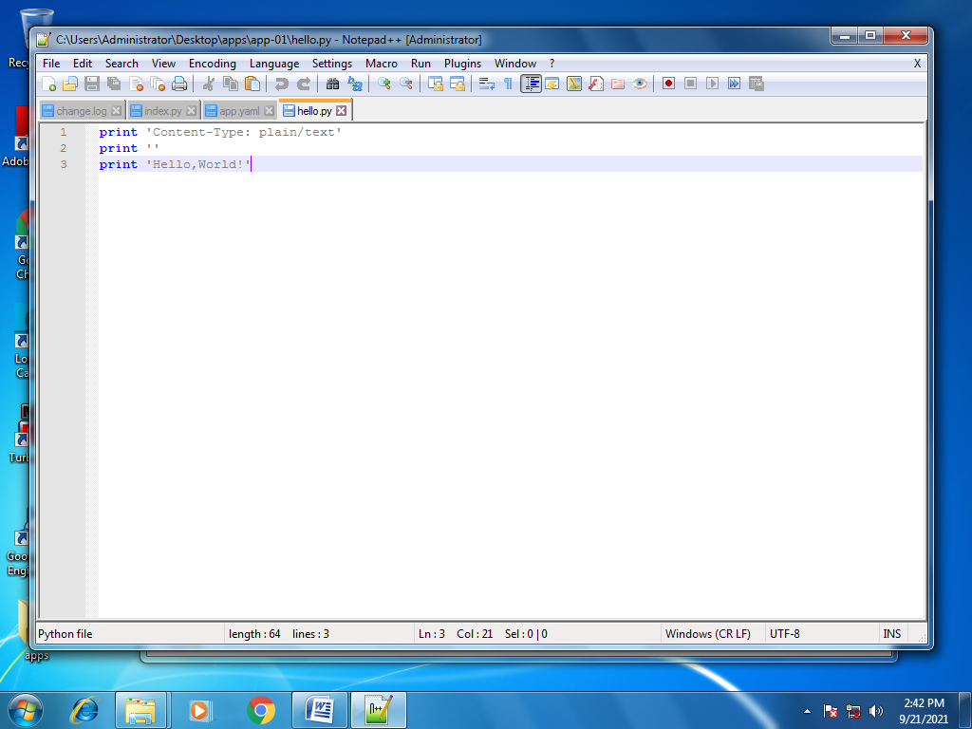

Step 2:

Create an app.yaml file and write the following code.

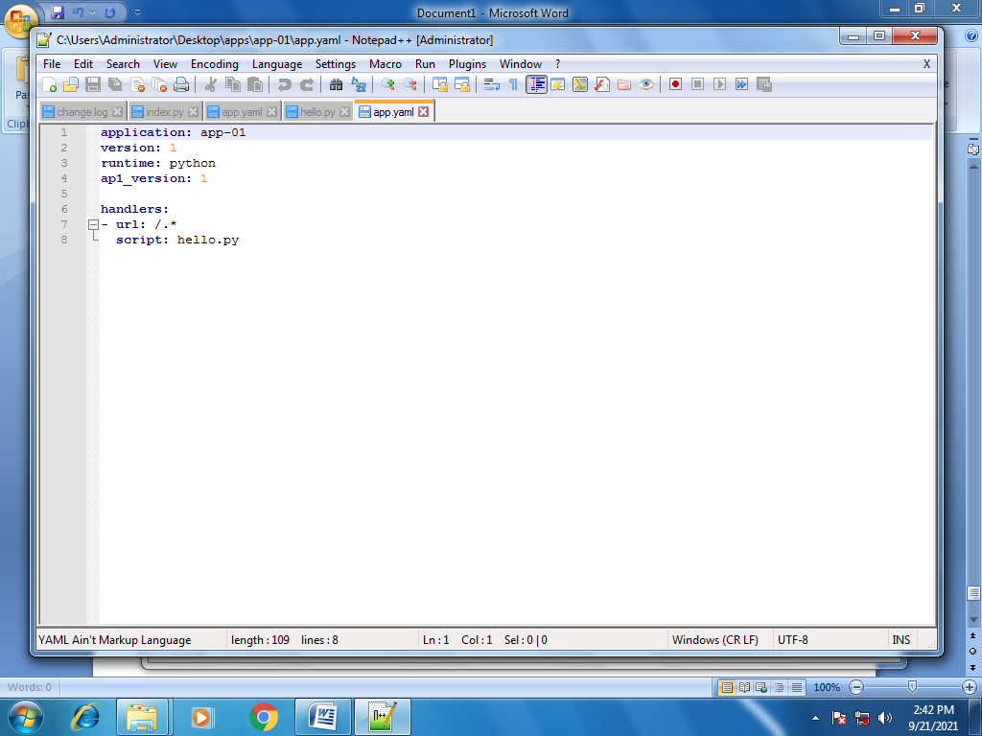

Step 3:

Launch Google App Engine. Select File->Create New Application.

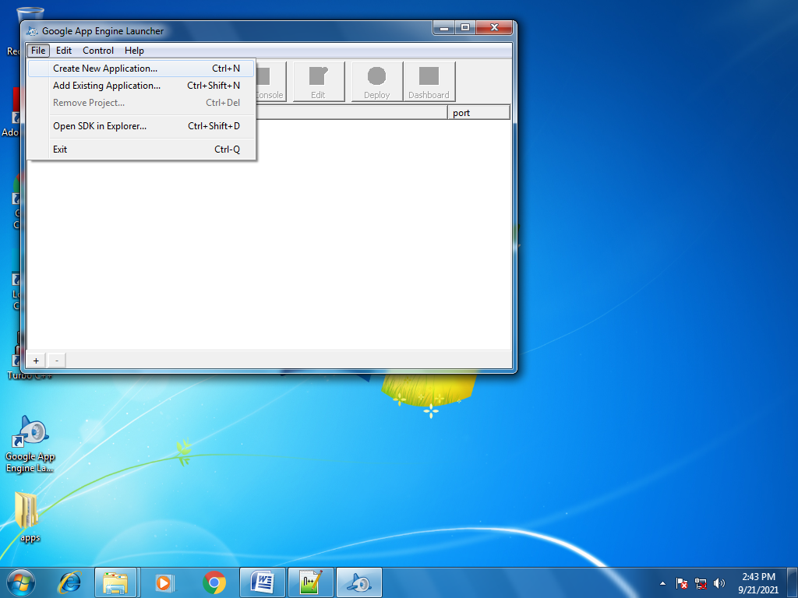

Step 4:

Select the correct folder(here it is apps->app-01). Click OK.

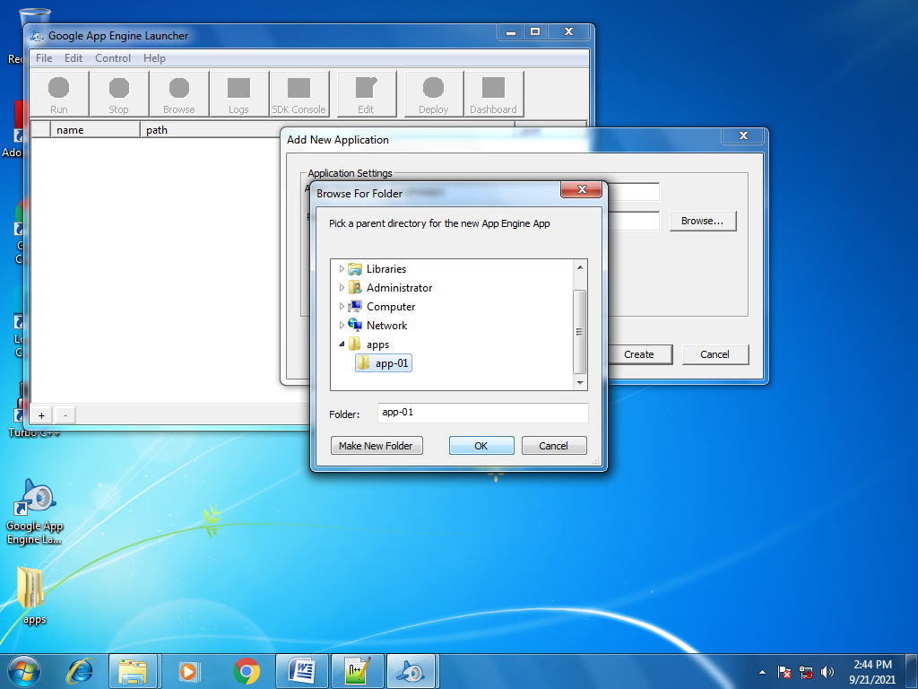

Step 5:

Set the Port to 8080 and click Create.

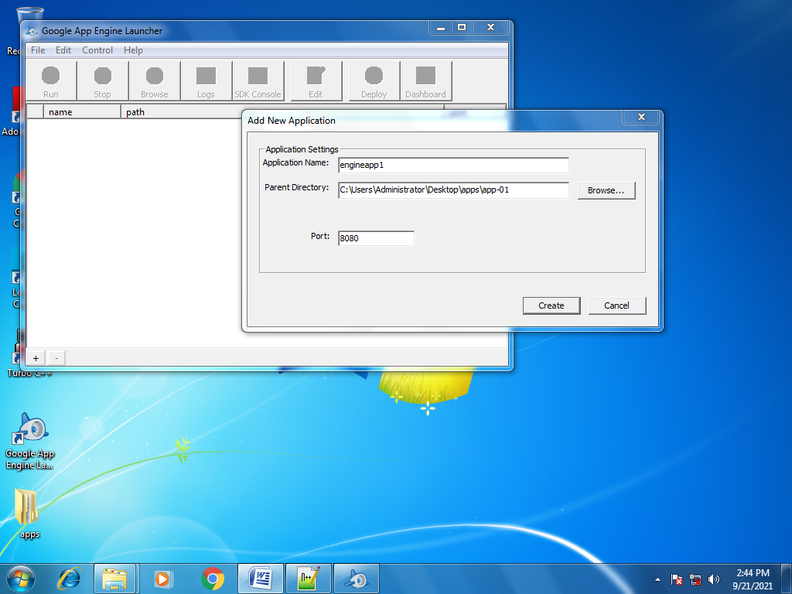

Step 6:

Click on Run.

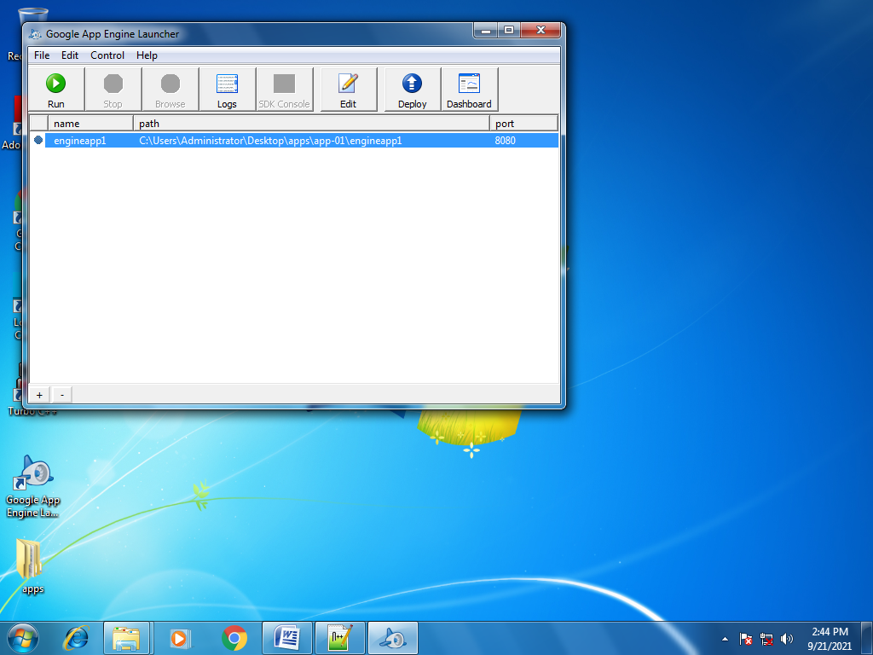

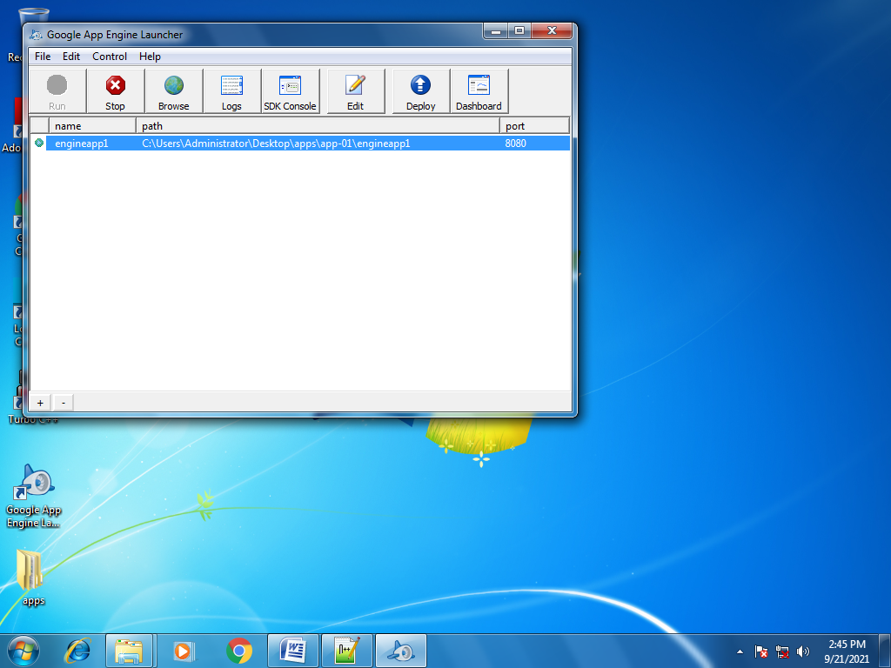

Step 7:

Go to <http://localhost:8080/> in desired browser. Output will be displayed.

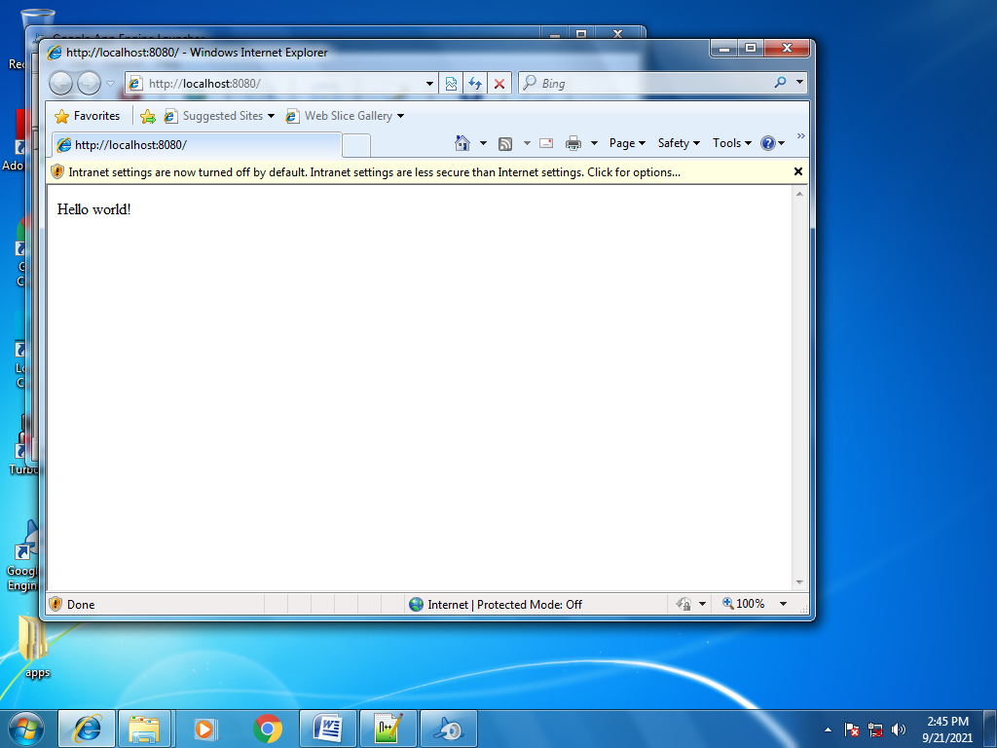

**RESULT :**

Thus the Google App Engine is installed and hello world app and other simple web applications is created using python/java.

|  |  |
| --- | --- |
| **Ex. No : 4**  **Date :** | **Use GAE launcher to launch the web applications.** |

**AIM :**

To use GAE launcher to launch the web applications.

**PROCEDURE :**

1. Then start the **GoogleAppEngineLauncher** program that can be found under

**Applications**. Use the **File** **-­>** **Add** **Existing** **Application** command and navigate into the

**apps** directory and select the **ae-­01-­trivial** folder.

1. Once you have added the application, select it so that you can control the application using

the launcher.

1. Watching the Log::You can watch the internal log of the actions that the web server is

performing when you are interacting with your application in the browser. Select your

application in the Launcher and press the **Logs** button to bring up a log window.

#### Dealing With Errors:With two files to edit, there are two general categories of errors that

#### you may encounter. If you make a mistake on the app.yaml file, the App Engine will not start

#### and your launcher will show a yellow icon near your application.

#### 

1. In this instance – the mistake is mis-­‐indenting the last line in the **app.yaml** (line 8).If you make

a syntax error in the **index.py** file, a Python trace back error will appear in your browser.

1. When you make a mistake in the **app.yaml** file – you must the fix the mistake and attempt to

start the application again. If you make a mistake in a file like i**ndex.py**, you can simply fix the

file and press refresh in your browser – there is no need to restart the server.

#### Shutting Down the Server:To shut down the server, use the Launcher, select your

#### application and press the Stop button.

**OUTPUT :**

Step-1:Open the Google App engine Launcher.

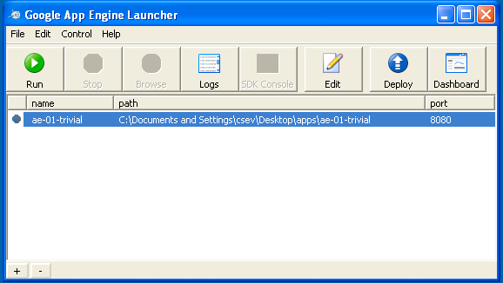

step-2:Check out for the errors over the program.

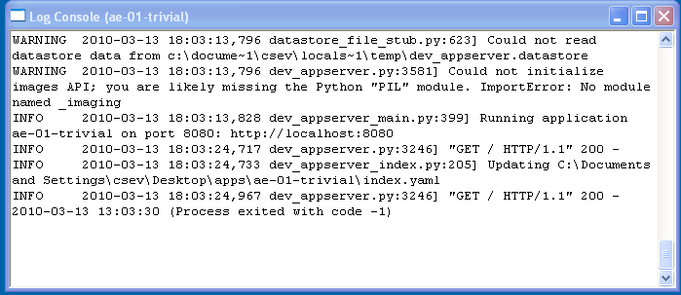

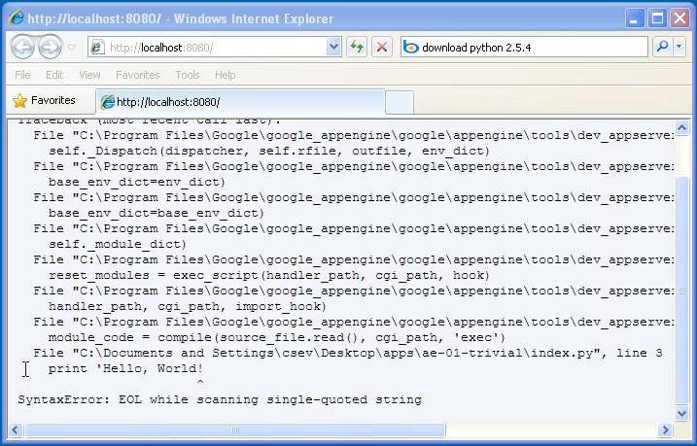

Step-3:Set path for the document.

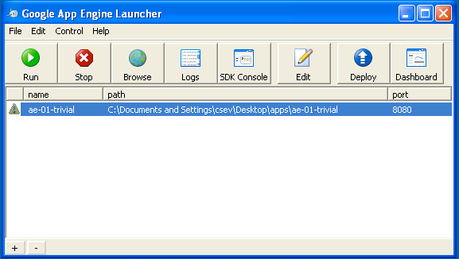

Step-4:Enter the code Log Console.

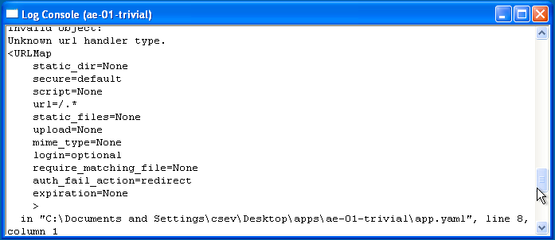

Step-6:Shut down the console.

**RESULT :**

Thus the GAE launcher is used to launch the web applicatons.

**AIM :**

To simulate a cloud scenario using CloudSim and run a scheduling algorithm that is not present in CloudSim.

|  |  |
| --- | --- |
| **Ex. No : 5**  **Date :** | **Simulate a cloud scenario using CloudSim and run a scheduling algorithm that is not present in CloudSim.** |

**PROCEDURE :**

1. Download CloudSim installable files from *<https://code.google.com/p/cloudsim/downloads/list>*

*and unzip*

Open Eclipse

1. Create a new Java Project: File -> New
2. Import an unpacked CloudSim project into the new Java Project
3. The first step is to initialise the CloudSim package by initialising the

CloudSim library, as follows:

CloudSim.init(num_user, calendar, trace_flag)

1. Data centres are the resource providers in CloudSim; hence, creation of data

centres is a second step. To create Datacenter, you need the

DatacenterCharacteristics object that stores the properties of a data centre

Such as architecture, OS, list of machines, allocation policy that covers the

time or spaceshared, the time zone and its price:

Datacenter datacenter9883 = new Datacenter(name, characteristics, new

VmAllocationPolicySimple(hostList),

1. The third step is to create a broker:

DatacenterBroker broker = createBroker();

1. The fourth step is to create one virtual machine unique ID of the VM,

userId ID of the VM’s owner, mips, number Of Pes amount of CPUs,

amount of RAM, amount of bandwidth, amount of storage, virtual

machine monitor, and cloudletScheduler policy for cloudlets:

Vm vm = new Vm(vmid, brokerId, mips, pesNumber, ram, bw, size, vmm, new CloudletSchedulerTimeShared())

1. Submit the VM list to the broker:

broker.submitVmList(vmlist)

1. Create a cloudlet with length, file size, output size, and utilisation model:

Cloudlet cloudlet = new Cloudlet(id, length, pesNumber, fileSize, outputSize, utilizationModel, utilizationMode

1. Submit the cloudlet list to the broker:

broker.submitCloudletList(cloudletList)

1. Start the simulation:

CloudSim startSimulation()

Sample Output from the Existing Example:

Starting CloudSimExample1... Initialising...

Starting CloudSim version 3.0 Datacenter_0 is starting...

>>>>>>>>>>>>>>>>>>>>>>>>>>>>>>>>null

Broker is starting... Entities started.

* 1. : Broker: Cloud Resource List received with 1 resource(s) 0.0: Broker: Trying to Create VM #0 in Datacenter_0
  2. : Broker: VM #0 has been created in Datacenter #2, Host #0

0.1: Broker: Sending cloudlet 0 to VM #0

400.1: Broker: Cloudlet 0 received

* 1. : Broker: All Cloudlets executed. Finishing... 400.1: Broker: Destroying VM #0

Broker is shutting down... Simulation: No more future events

CloudInformationService: Notify all CloudSim entities for shutting down. Datacenter_0 is shutting down...

Broker is shutting down... Simulation completed.

Simulation completed.

========== OUTPUT ==========

Cloudlet ID STATUS Data center ID VM ID Time Start Time Finish Time 0 SUCCESS 2 0 400 0.1 400.1

*****Datacenter: Datacenter_0***** User id Debt

3 35.6

CloudSimExample1 finished!

**OUTPUT :**

**Step 1:**

Go to <http://cloudbus.org/cloudsim/> and click on download – <https://github.com/Cloudslab/cloudsim/releases>

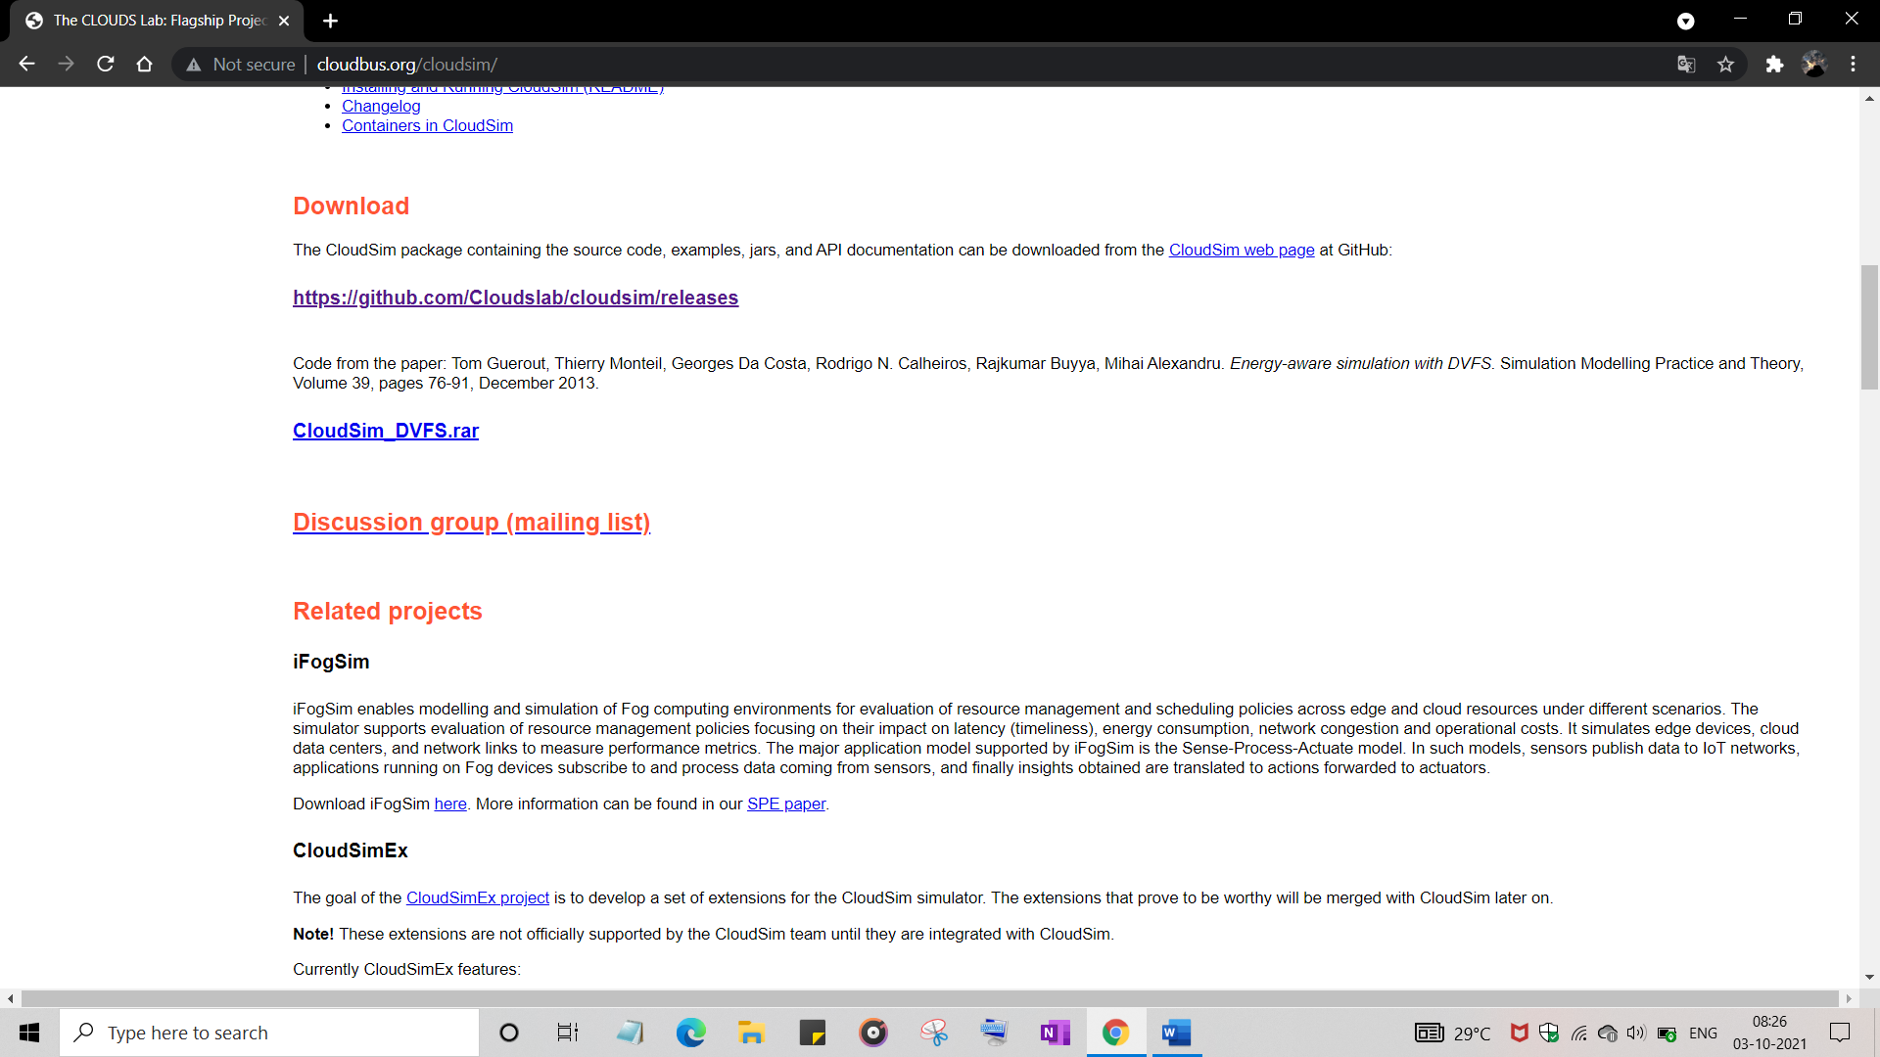

**Step 2:**

Now download the cloudsim-3.0.3.zip file and after download extract the file.

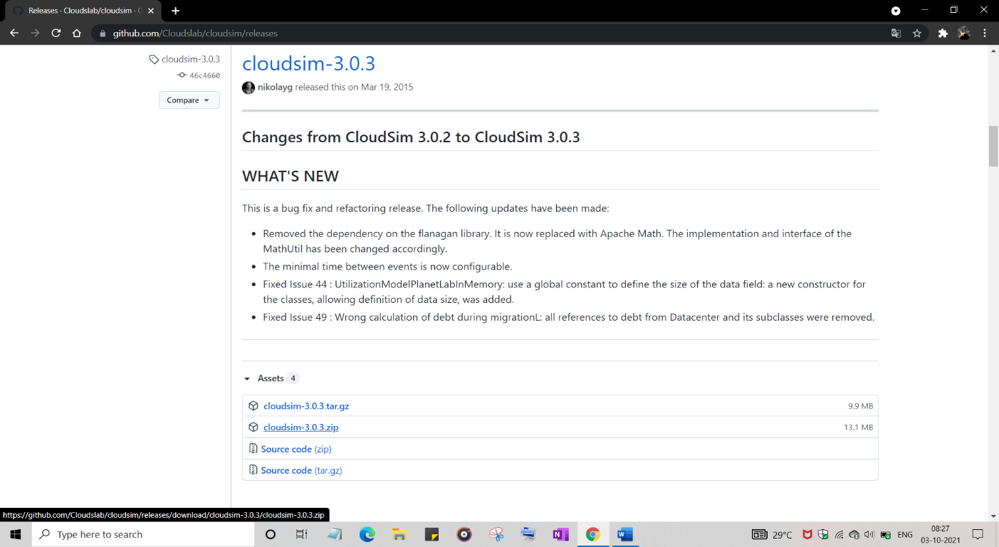

**Step 3:**

Now open NetBeans IDE and select File-> New Project.

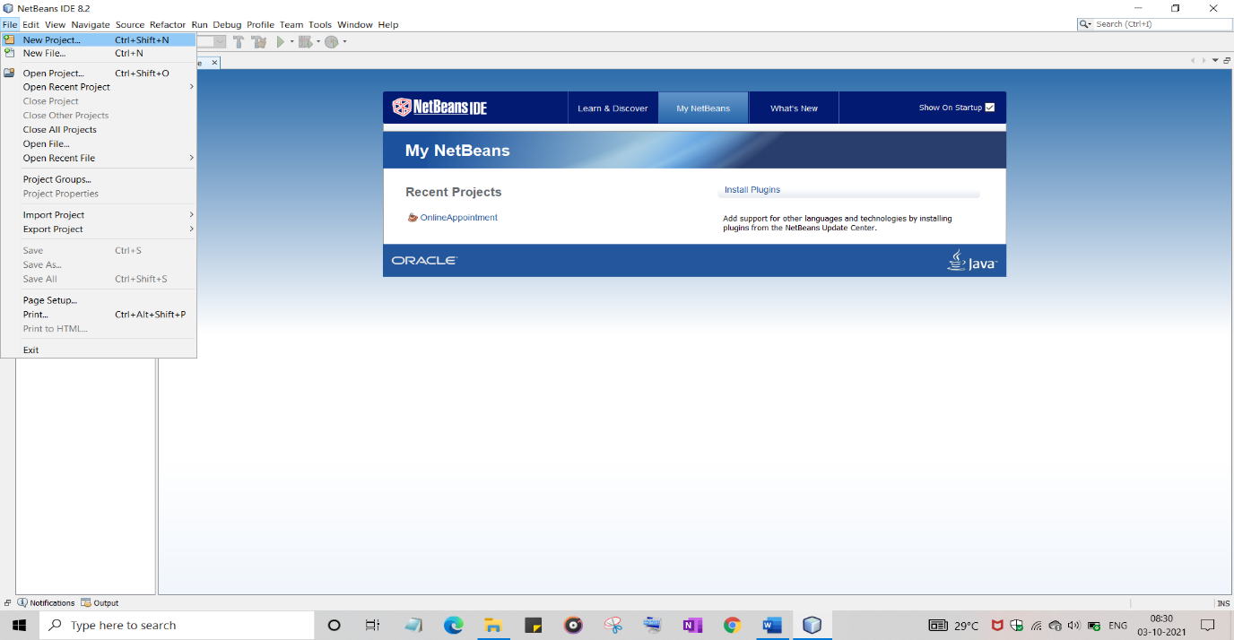

**Step 4:**

Click on Java -> Java application then click next.

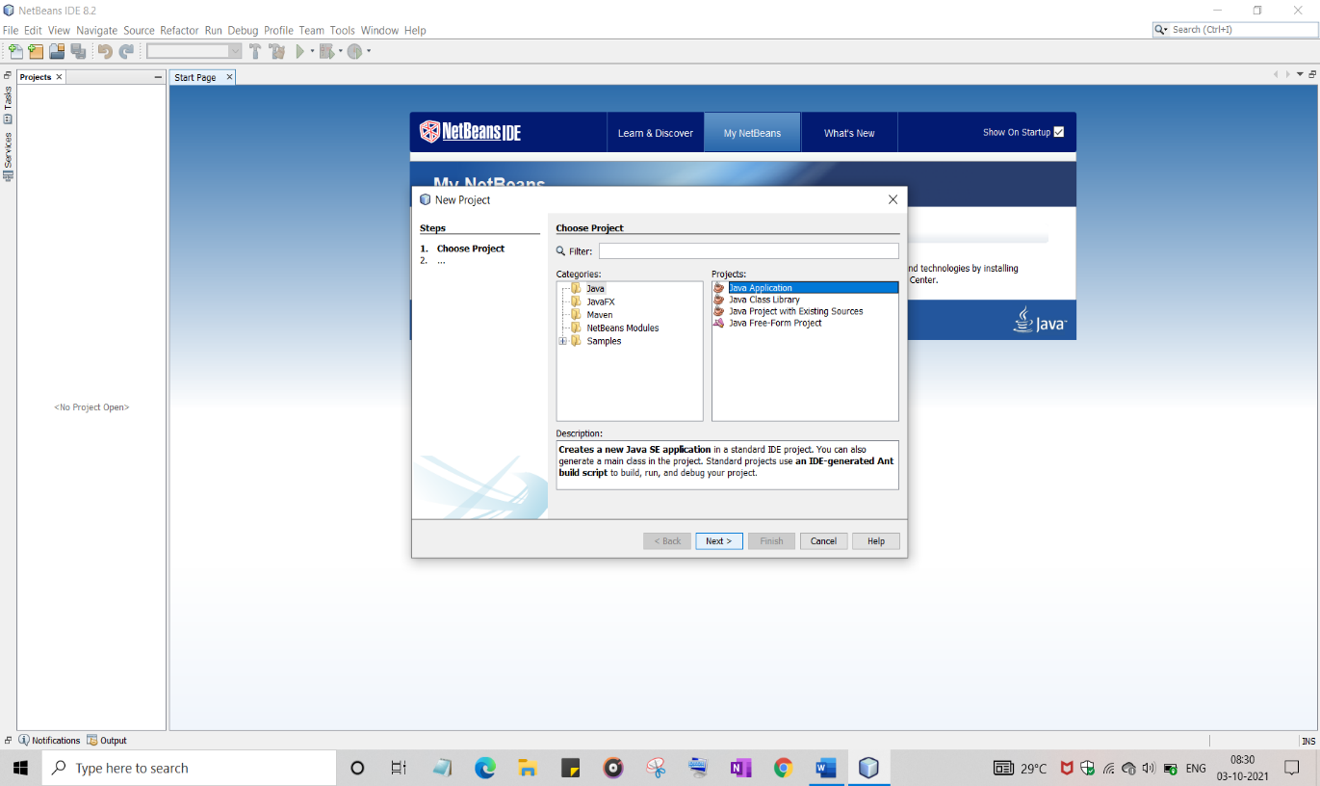

**Step 5:**

Give project name as Cloudsim and click finish.

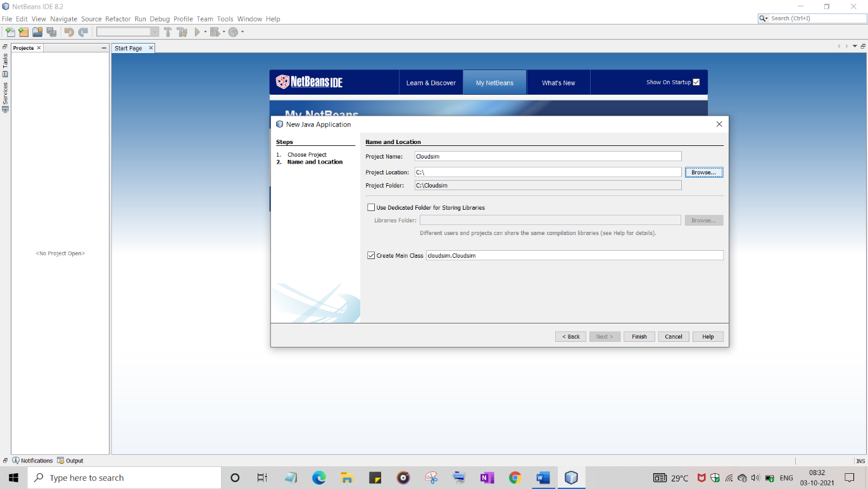

**Step 6:**

Now right click on libraries option in the left side and select Add jar /folder.

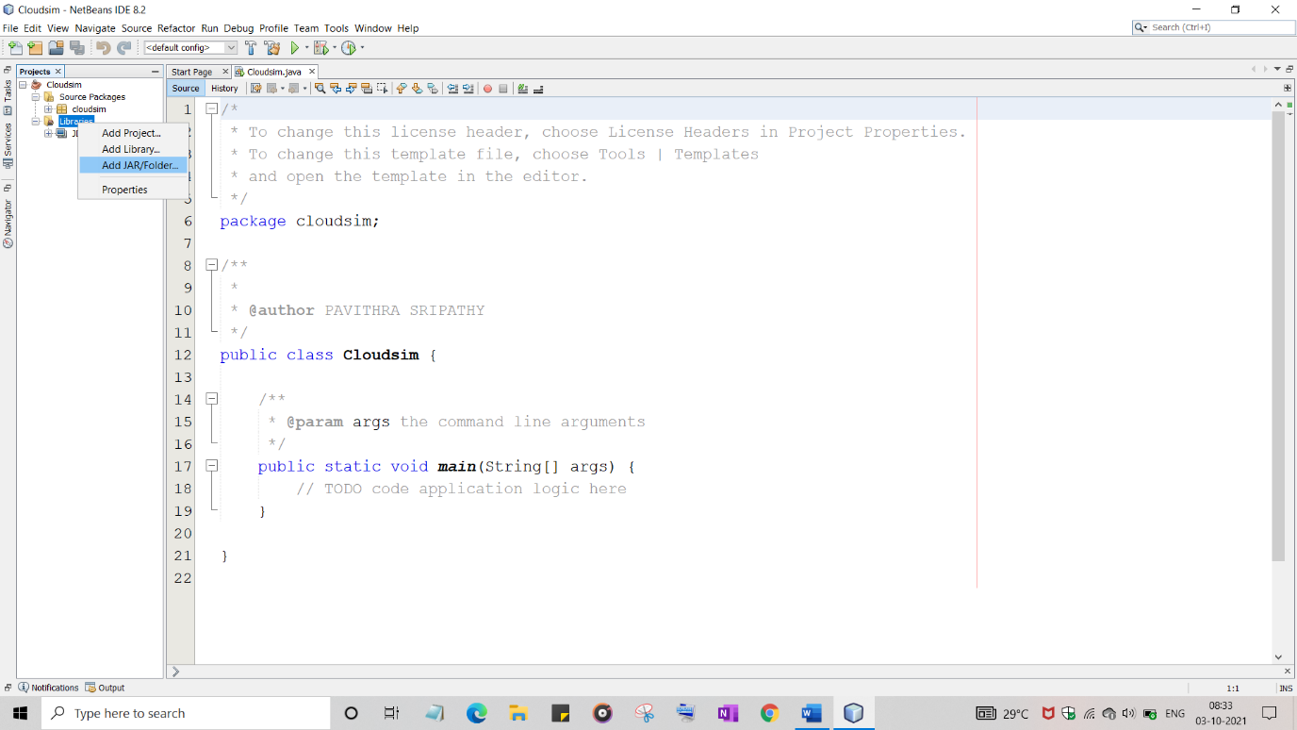

**Step 7:**

From the extracted cloudsim folder click on the jars folder and select cloudsim-3.0.3.jar and click open.

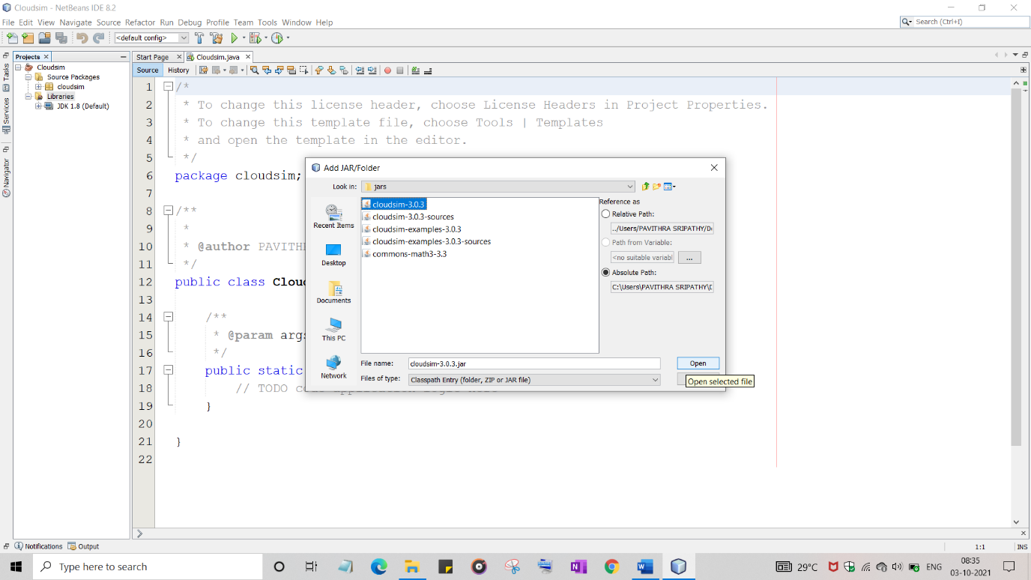

**Step 8:**

In the cloudsim-3.0.3.zip folder copy the folder named examples and paste it in src of your project folder

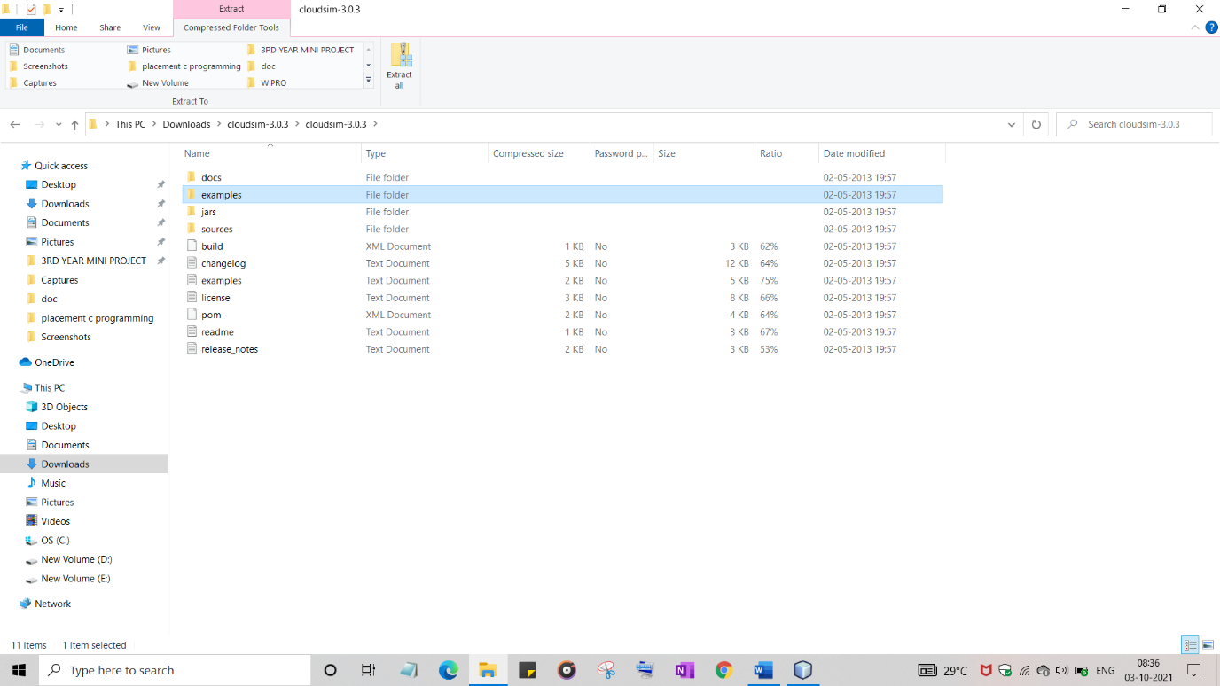

**Step 9:**

Once done the example folders appear in NetBeans, now click on CloudExample1.java

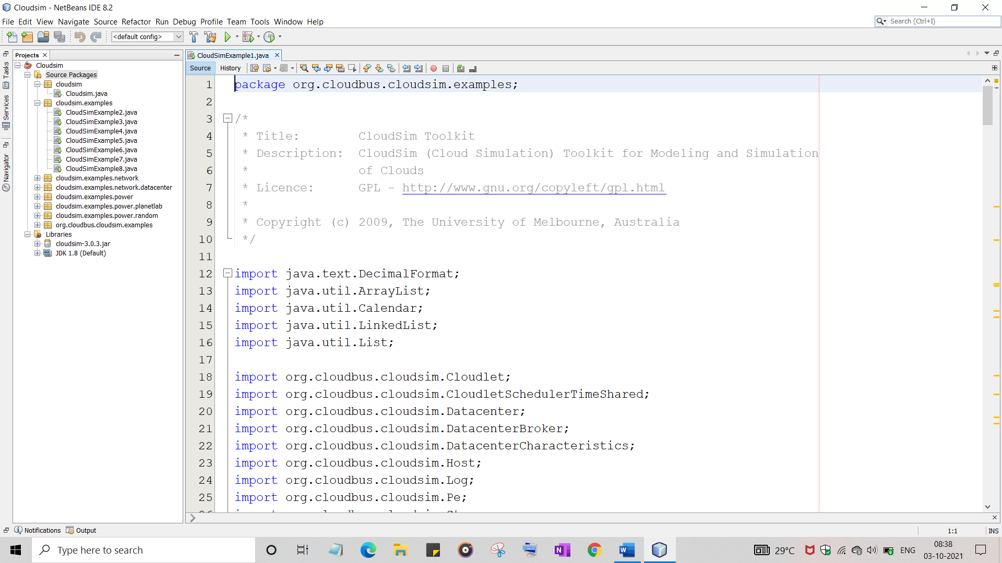

**Step 10:**

Right click on the code and click run file

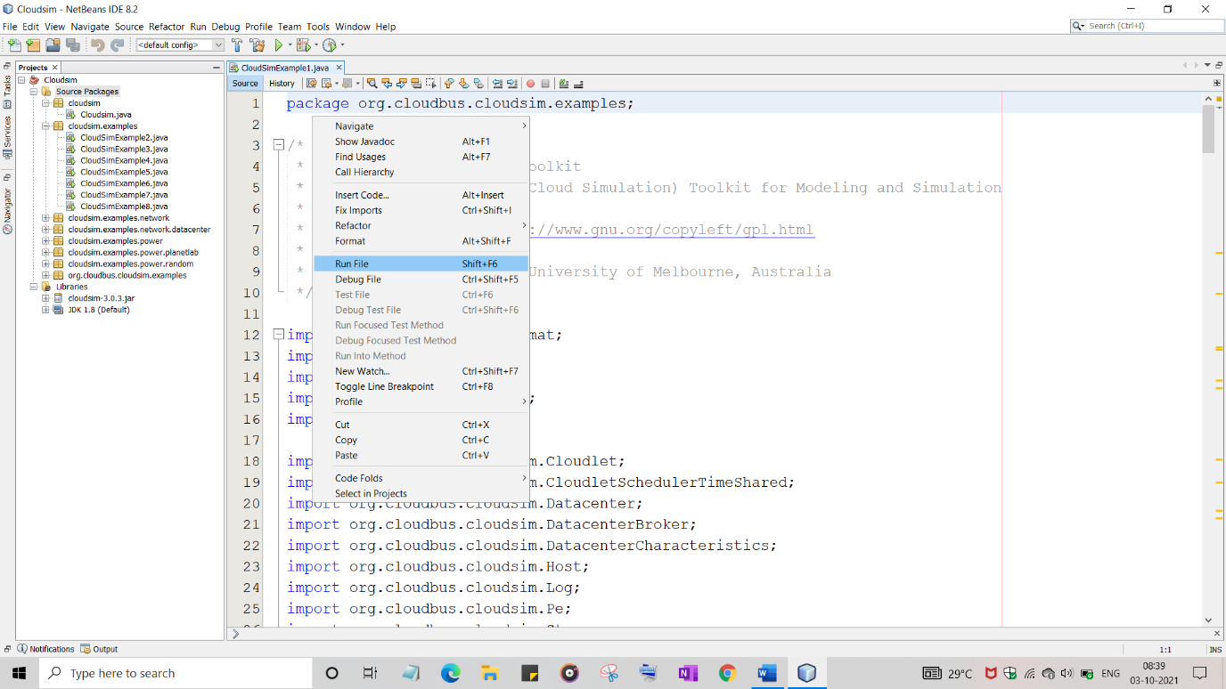

**Step 11:**

The Sample Output from the Existing Example is obtained.

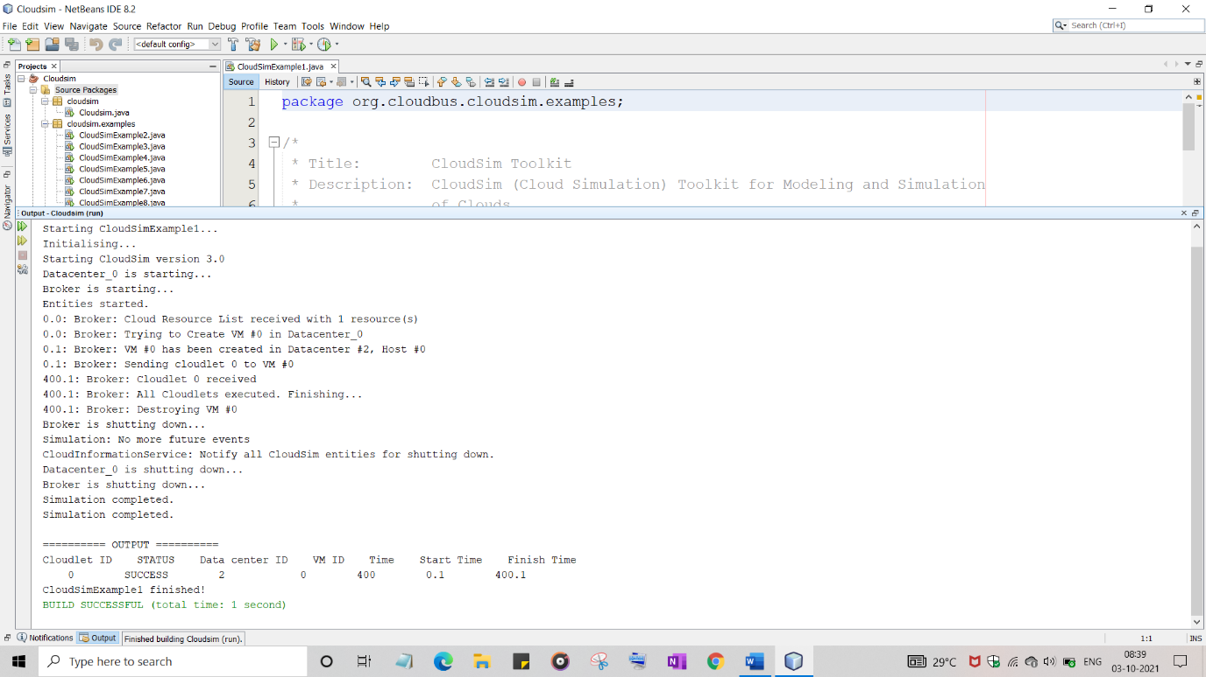

**RESULT :**

Thus a cloud scenario is simulated using CloudSim and a scheduling algorithm that is not present in CloudSim is executed successfully.

|  |  |
| --- | --- |
| **Ex. No : 6**  **Date :** | **Find a procedure to transfer the files from one virtual machine to another virtual machine.** |

**AIM :**

Tofind a procedure to transfer the files from one virtual machine to another virtual machine.

**PROCEDURE:**

* + 1. One can copy few (or more) lines with ***copy & paste*** mechanism.

For this you need [to share clipboard between host OS and guest OS](https://superuser.com/questions/42134/virtualbox-shared-clipboard), installing **Guest Addition** on both the virtual machines (probably setting *bidirectional* and restarting them). You *copy* from *guest OS* in the clipboard that is shared with the *host OS*.

Then you *paste* from the *host OS* to the second *guest OS*.

* + 1. You can enable **drag and drop** too with the same method (Click on the machine, settings, general, advanced, drag and drop: set to *bidirectional* )
    2. You can have **common *Shared Folders*** on both virtual machines and use one of the directory shared as buffer to copy.

Installing **Guest Additions** you have the possibility to set [Shared Folders too](https://www.virtualbox.org/manual/ch04.html" \l "sharedfolders). As you put a file in a shared folder from *host OS* or from *guest OS*, is immediately visible to the other. (Keep in mind that can arise some problems for date/time of the files when there are different clock settings on the different virtual machines).

*If you use the same folder shared on more machines you can exchange files directly copying them in this folder.*

* + 1. You can use **usual method to copy files between 2 different computer** with client-server application. (e.g. scp with sshd active for linux, winscp... [you can get some info about SSH servers e.g. here](http://en.wikipedia.org/wiki/Comparison_of_SSH_servers))

You need an active server (sshd) on the receiving machine and a client on the sending machine. Of course you need to have the authorization setted (via password or, better, via an [automatic authentication method](https://help.github.com/articles/generating-ssh-keys)).

**Note:** many Linux/Ubuntu distribution install sshd by default: you can see if it is running with pgrep sshd from a shell. You can install with sudo apt-get install openssh-server.

* + 1. You can **mount part of the file system** of a virtual machine via [NFS](http://en.wikipedia.org/wiki/Network_File_System) or [SSHFS](http://en.wikipedia.org/wiki/SSHFS) on the other, or you can **share file and directory** with Samba.

You may find interesting the article [Sharing files between guest and host without](https://www.virtualbox.org/wiki/Sharing_files_on_OSE) [VirtualBox shared folders](https://www.virtualbox.org/wiki/Sharing_files_on_OSE) with detailed step by step instructions.

* + 1. Each virtual machine is an instance of a program *owned* by an *user* in the hosting operative system and should undergo the restrictions of the *user* in the *hosting OS*.
    2. Enable *Drag & drop* to be cosy with the Windows machines and the *Shared folders* or to be cosy with Linux.
    3. When you will need to be fast with Linux **you will feel the need** of ssh-keygen andto [Generate once SSH Keys](https://help.github.com/articles/generating-ssh-keys) to copy files on/from a remote machine without writing password anymore. In this way it functions bash auto-completion remotely.

**OUTPUT :**

**Step-1:**

Install the VMware

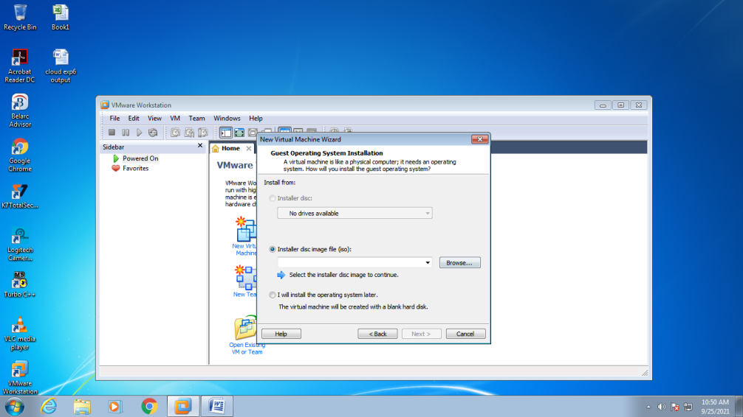

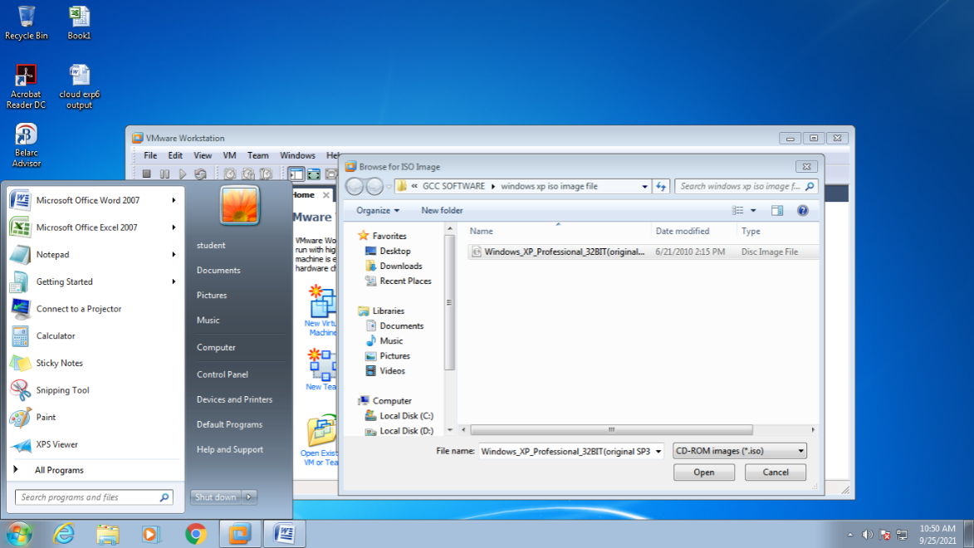

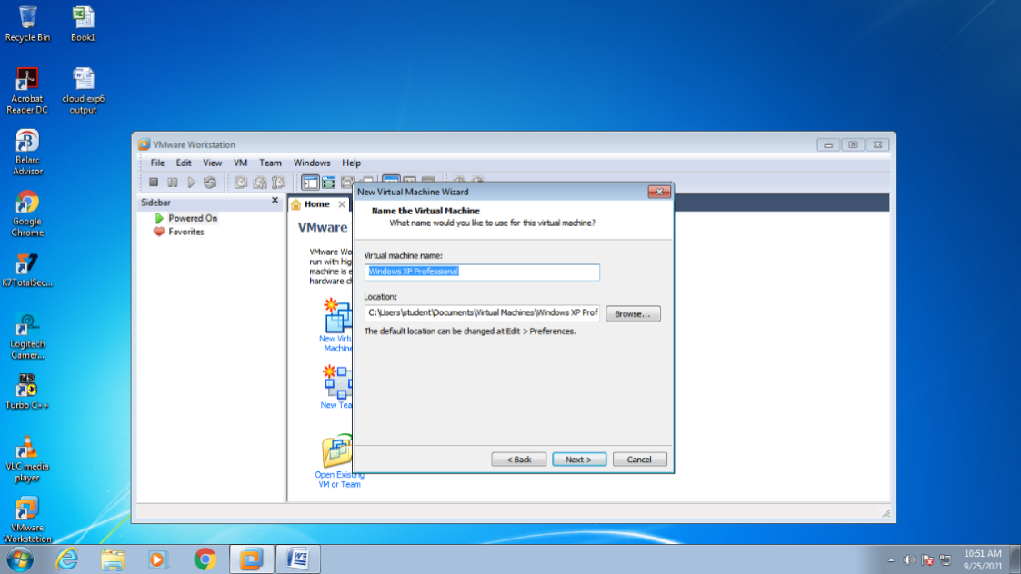

**Step-2:**

Set up the VMware.

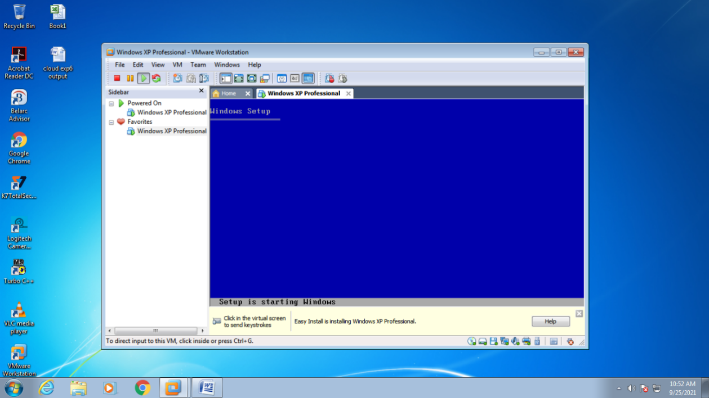

**Step-3:**

Setup the Windows XP in the VMware.

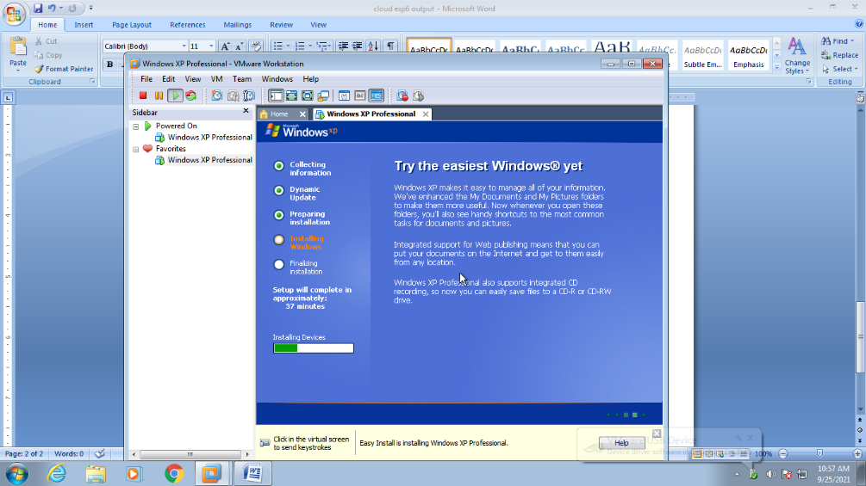

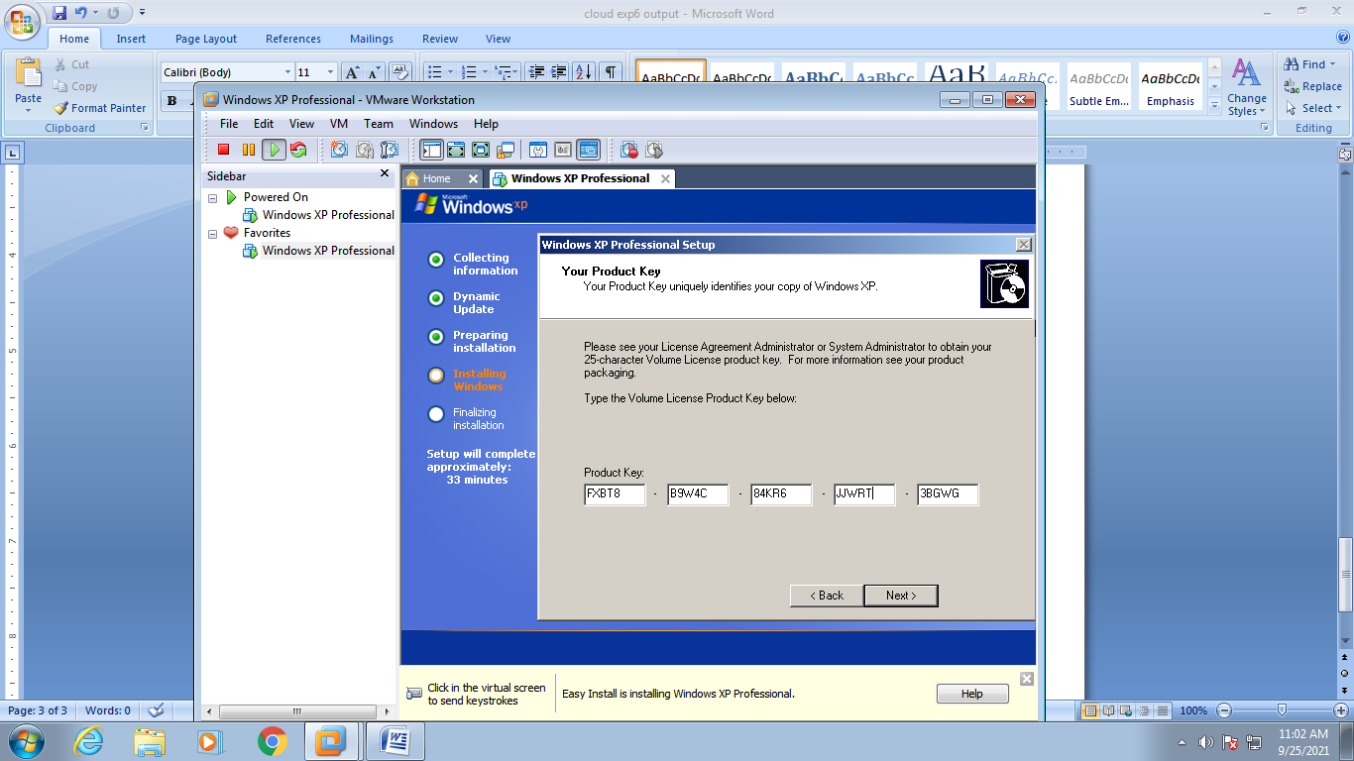

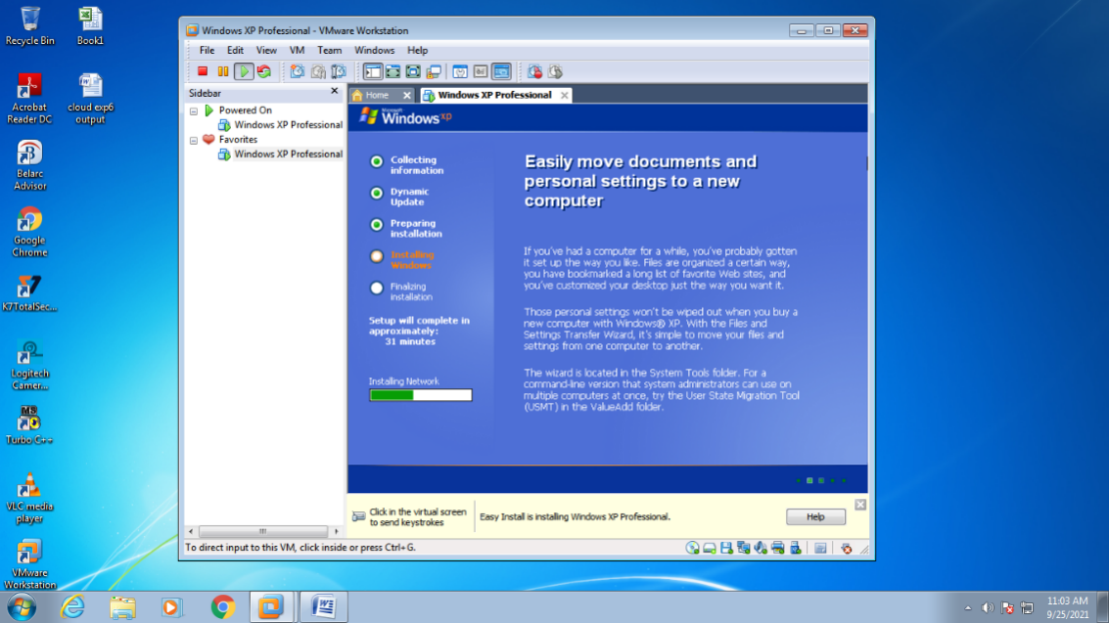

**Step-4:**

Setup the VMware tool.

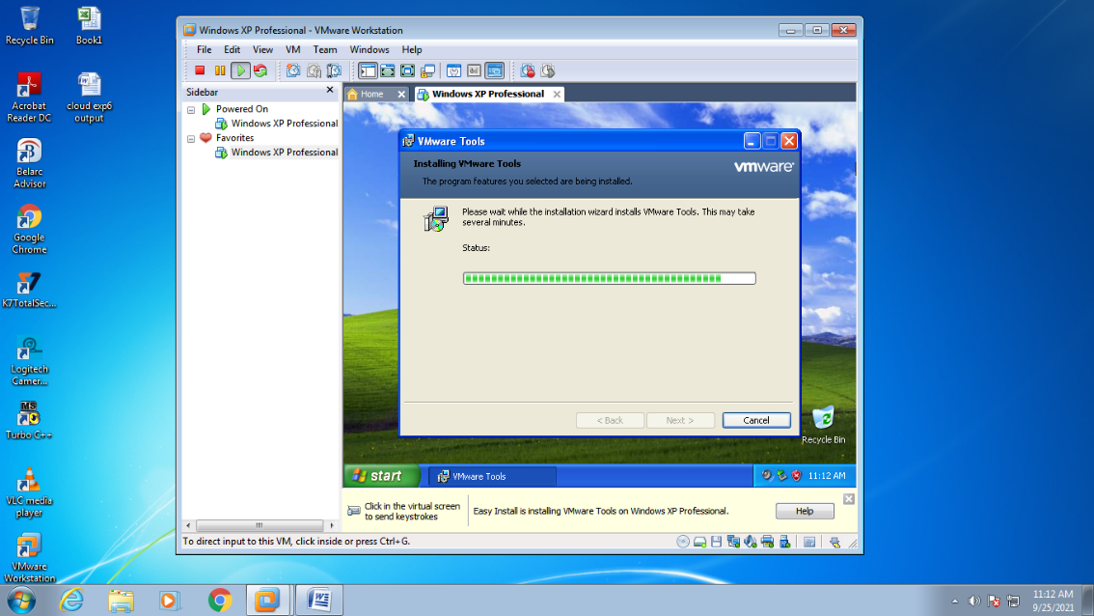

**Step-5:**

Open the system.

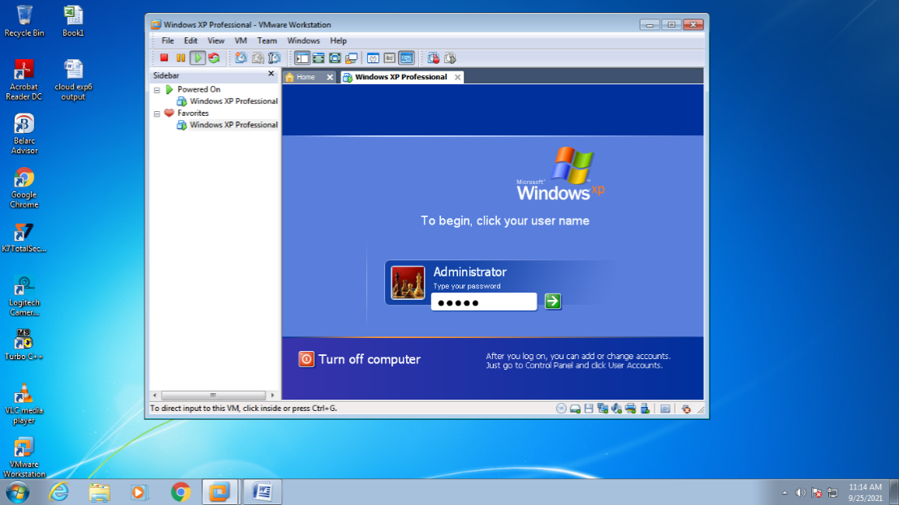

**Step-6:**

Set the VMware in the OS for file transfer.

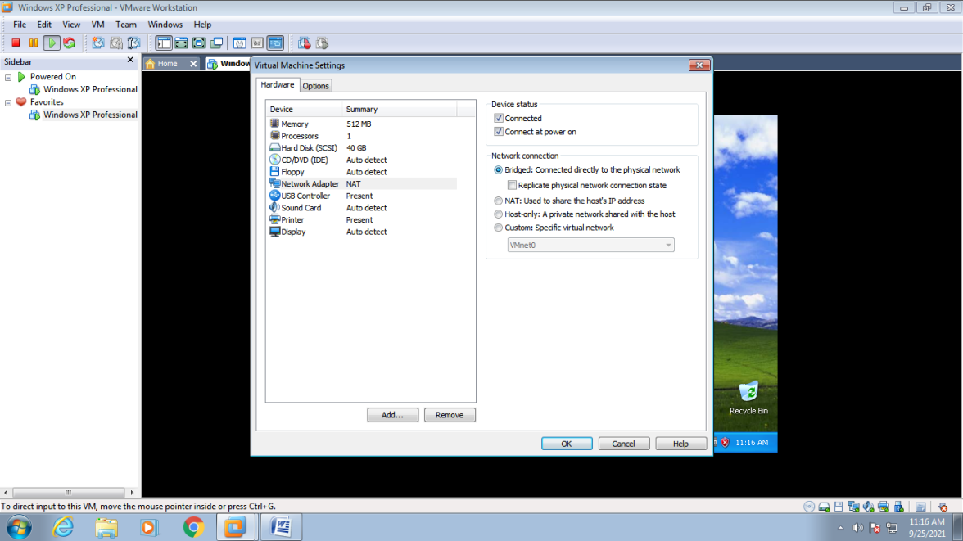

**Step-7:**

Select the file to be transferred.

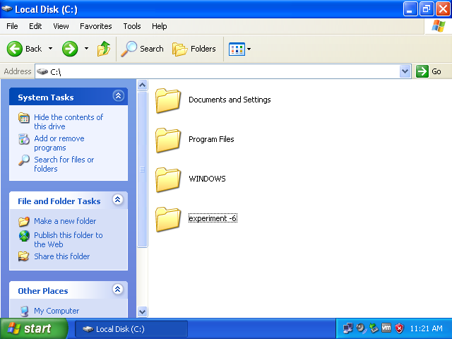

**Step-8:**

Connect to the VM

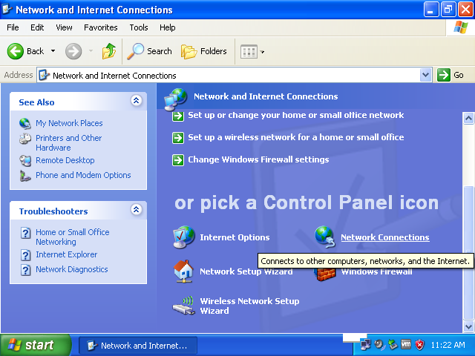

**Step-9:**

Check the properties of the LAN.

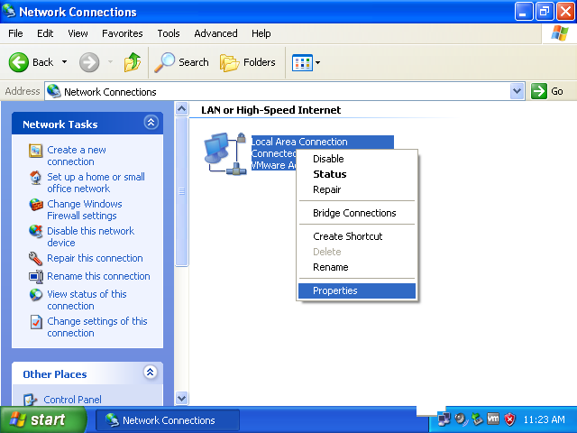

**Step-10:**

Setup the TCP/IP in the LAN properties and also get the IP address.

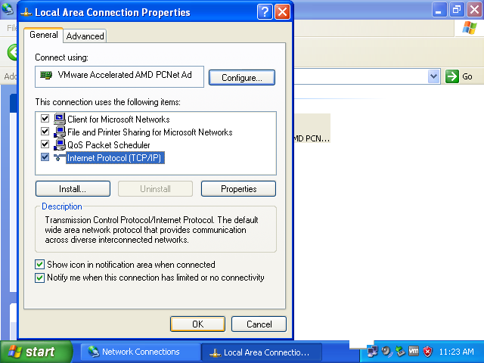

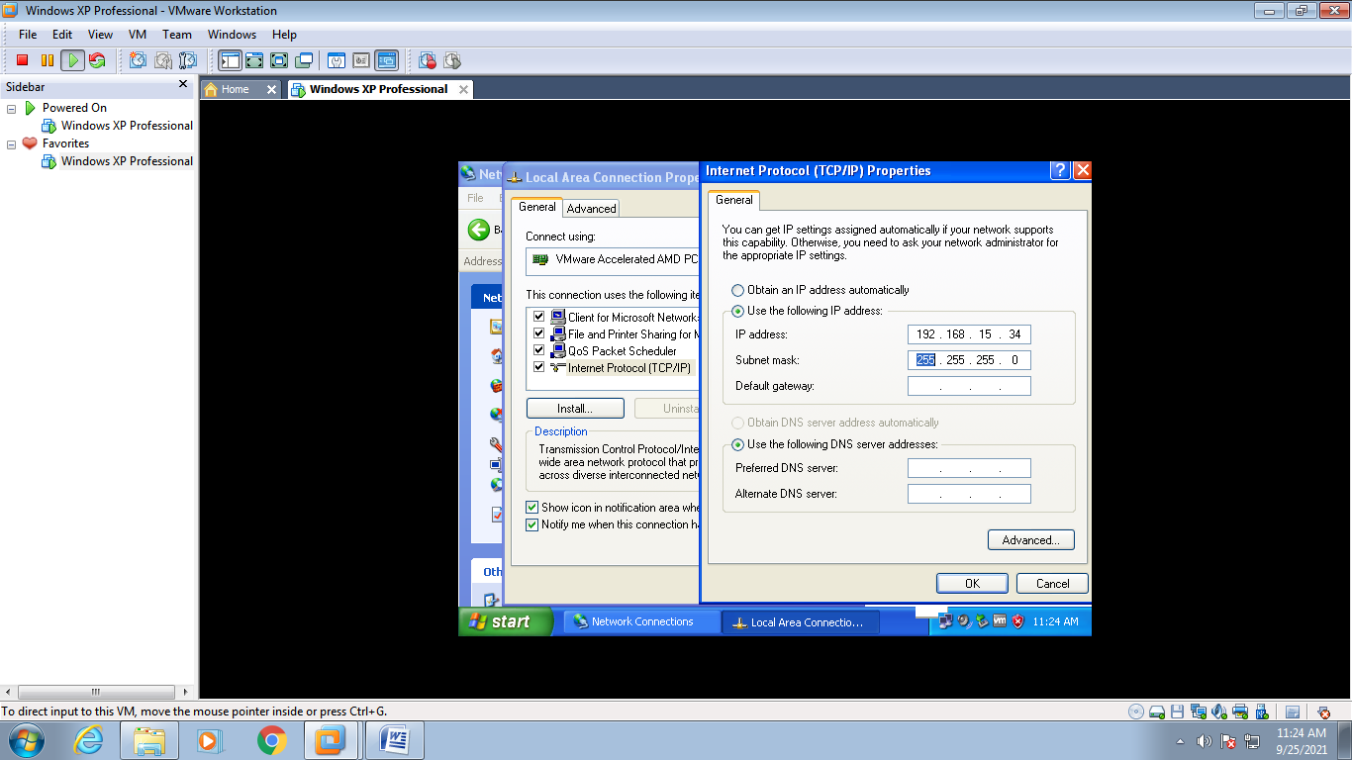

**Step-11:**

Now enter the file name correctly which must be transferred .

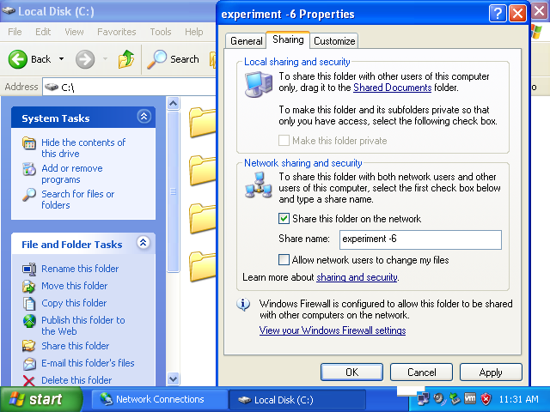

**Step-12:**

Click yes.

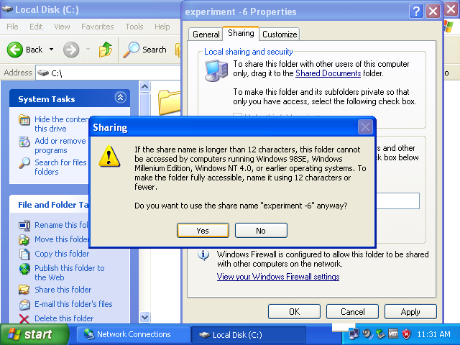

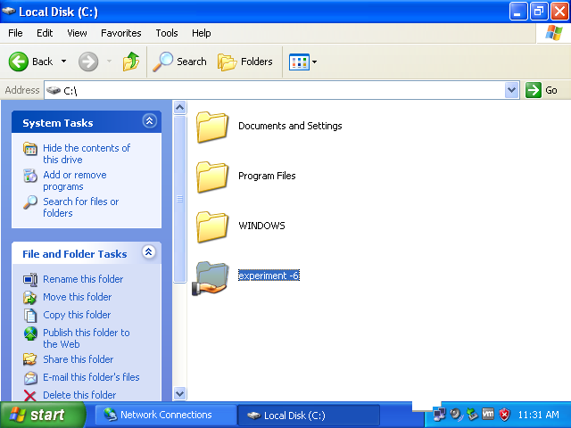

The file is transferred.

**RESULT :**

Thus the files from one virtual machine is transferred to another virtual machine.

|  |  |
| --- | --- |
| **Ex. No : 7**  **Date :** | **Find a procedure to launch virtual machine using trystack (Online Openstack Demo Version)** |

**AIM :**

To find a procedure to launch virtual machine using trystack (Online Openstack Demo Version).

**PROCEDURE :**

**[OpenStack](http://www.openstack.org/)** is an open-source software cloud computing platform. OpenStack is primarily used for deploying an infrastructure as a service (IaaS) solution like Amazon Web Service (AWS). In other words, you can *make your own AWS* by using OpenStack. If you want to try out OpenStack, **[TryStack](http://trystack.org/)** is the easiest and free way to do it.

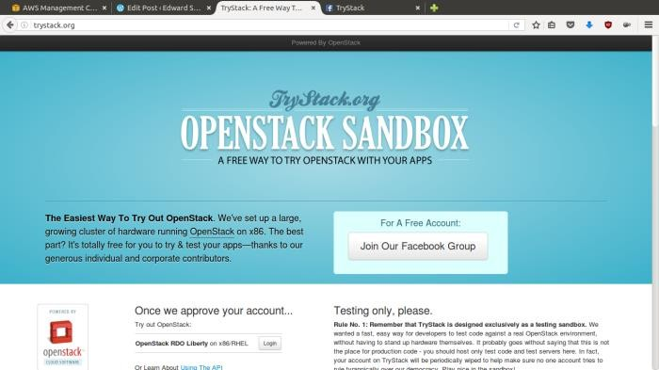

OpenStack Compute Dashboard

**Step 1: Create Network**

Network? Yes, the network in here is our own local network. So, your instances will be not mixed up with the others. You can imagine this as your own LAN (Local Area Network) in the cloud.

1. Go to **Network > Networks** and then click **Create Network**.
2. In **Network** tab, fill **Network Name** for example internal and then click **Next**.
3. In **Subnet** tab,
   1. Fill **Network Address** with appropriate CIDR, for example 192.168.1.0/24. Use [private network CIDR block](https://en.wikipedia.org/wiki/Private_network) as the best practice.
   2. Select **IP Version** with appropriate IP version, in this case IPv4.
   3. Click **Next**.

In **Subnet Details** tab, fill **DNS Name Servers** with 8.8.8.8 (Google DNS) and then click **Create**.

**Step 2:Create Instance**

1. Go to **Compute > Instances** and then click **Launch Instance**.
2. In **Details** tab,
   1. Fill **Instance Name**, for example Ubuntu 1.
   2. Select **Flavor**, for example m1.medium.
   3. Fill **Instance Count** with **1**.
   4. Select **Instance Boot Source** with **Boot from Image**.
   5. Select **Image Name** with **Ubuntu 14.04 amd64 (243.7 MB)** if you want install Ubuntu

14.04 in your virtual machine.

1. In **Access & Security** tab,
   1. Click [**+**] button of **Key Pair** to import key pair. This key pair is a public and private key that we will use to connect to the instance from our machine.
   2. In **Import Key Pair** dialog,
      1. Fill **Key Pair Name** with your machine name (for example Edward-Key).
      2. Fill **Public Key** with your **SSH public key** (usually is in ~/.ssh/id_rsa.pub). See description in Import Key Pair dialog box for more information. If you are using Windows, you can use **Puttygen** to generate key pair.
      3. Click **Import key pair**.
   3. In **Security Groups**, mark/check **default**.
   4. In **Networking** tab,
      1. In **Selected Networks**, select network that have been created in Step 1, for example internal.
   5. Click **Launch**.
   6. If you want to create multiple instances, you can repeat step 1-5. I created one more instance with instance name Ubuntu 2.

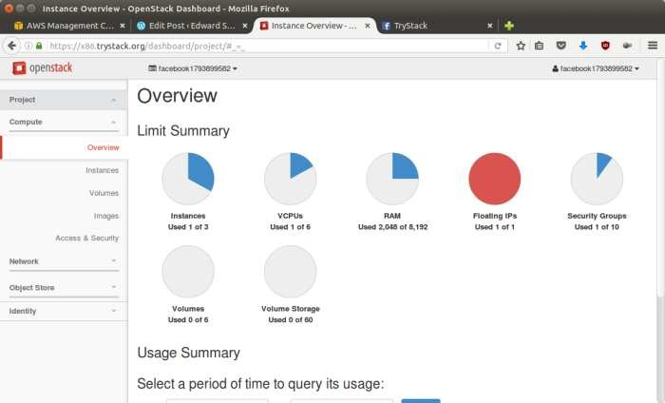

**Step 3: Create Router**

I guess you already know what router is. In the step 1, we created our network, but it is isolated. It doesn’t connect to the internet. To make our network has an internet connection, we need a router that running as the gateway to the internet.

1. Go to **Network > Routers** and then click **Create Router**.
2. Fill **Router Name** for example router1 and then click **Create router**.
3. Click on your **router name link**, for example router1, **Router Details** page.
4. Click **Set Gateway** button in upper right:
   1. Select **External networks** with **external**.
   2. Then **OK**.
5. Click **Add Interface** button.
   1. Select **Subnet** with the network that you have been created in Step 1.
   2. Click **Add interface**.
6. Go to **Network > Network Topology**. You will see the network topology. In the example, there are two network, i.e. external and internal, those are bridged by a router. There are

instances those are joined to internal network.

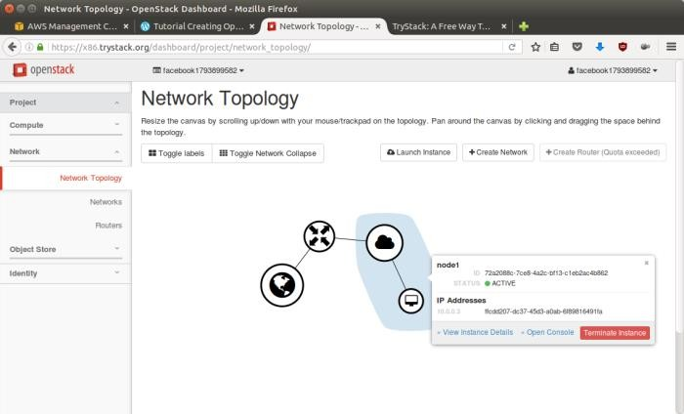

**Step 4: Configure floating IP address**

1. Go to **Compute > Instance**.
2. In one of your instances, click **More > Associate Floating IP**.
3. In **IP Address**, click Plus [**+**].
4. Select **Pool** to **external** and then click **Allocate IP**.
5. Click **Associate**.
6. Now you will get a public IP, e.g. 8.21.28.120, for your instance.

**Step 5: Configure Access & Security**

OpenStack has a feature like a firewall. It can whitelist/blacklist your in/out connection. It is called *Security Group*.

1. Go to **Compute > Access & Security** and then open **Security Groups** tab.
2. In **default** row, click **Manage Rules**.
3. Click **Add Rule**, choose **ALL ICMP** rule to enable ping into your instance, and then click **Add**.
4. Click **Add Rule**, choose **HTTP** rule to open HTTP port (port 80), and then click **Add**.
5. Click **Add Rule**, choose **SSH** rule to open SSH port (port 22), and then click **Add**.
6. You can open other ports by creating new rules.

**Step 6: SSH to Your Instance**

Now, you can SSH your instances to the floating IP address that you got in the step 4. If you are using Ubuntu image, the SSH user will be ubuntu.

**RESULT :**

Thus the virtual machine using trystack (Online Openstack Demo Version) is launched successfully.

|  |  |
| --- | --- |
| **Ex. No : 8**  **Date :** | **Install Hadoop single node cluster and run simple applications like wordcount.** |

**AIM :**

To install Hadoop single node cluster and run simple applications like wordcount.

**PROCEDURE :**

1. Install hadoop.

2. Start all services using the command.

hduser@prince-VirtualBox:/usr/local/hadoop/bin$ jps

3242 Jps

hduser@prince-VirtualBox:/usr/local/hadoop/bin$ **start-all.sh**

This script is Deprecated. Instead use start-dfs.sh and start-yarn.sh

16/09/15 15:38:49 WARN util.NativeCodeLoader: Unable to load native-hadoop library for your platform... using builtin-java classes where applicable

Starting namenodes on [localhost]

localhost: starting namenode, logging to /usr/local/hadoop/logs/hadoop-hduser-namenode-prince-VirtualBox.out

localhost: starting datanode, logging to /usr/local/hadoop/logs/hadoop-hduser-datanode-prince-VirtualBox.out

Starting secondary namenodes [0.0.0.0]

0.0.0.0: starting secondarynamenode, logging to /usr/local/hadoop/logs/hadoop-hduser-secondarynamenode-prince-VirtualBox.out

16/09/15 15:39:26 WARN util.NativeCodeLoader: Unable to load native-hadoop library for your platform... using builtin-java classes where applicable

starting yarn daemons

startingresourcemanager, logging to /usr/local/hadoop/logs/yarn-hduser-resourcemanager-prince-VirtualBox.out

localhost: starting nodemanager, logging to /usr/local/hadoop/logs/yarn-hduser-nodemanager-prince-VirtualBox.out

hduser@prince-VirtualBox:/usr/local/hadoop/bin$ **jps**

16098 NameNode

16214 DataNode

16761 NodeManager

16636 ResourceManager

16429 SecondaryNameNode

19231 Jps

**PROGRAM CODING:**

hduser@prince-VirtualBox:/usr/local/hadoop/bin$ **nano wordcount7.java**

importjava.io.IOException;

importjava.util.StringTokenizer;

importorg.apache.hadoop.conf.Configuration;

importorg.apache.hadoop.fs.Path;

importorg.apache.hadoop.io.IntWritable;

importorg.apache.hadoop.io.Text;

importorg.apache.hadoop.mapreduce.Job;

importorg.apache.hadoop.mapreduce.Mapper;

importorg.apache.hadoop.mapreduce.Reducer;

importorg.apache.hadoop.mapreduce.lib.input.FileInputFormat;

importorg.apache.hadoop.mapreduce.lib.output.FileOutputFormat;

public class wordcount7 {

public static class TokenizerMapper

extends Mapper<Object, Text, Text, IntWritable>{

private final static IntWritable one = new IntWritable(1);

private Text word = new Text();

public void map(Object key, Text value, Context context

) throws IOException, InterruptedException {

StringTokenizeritr = new StringTokenizer(value.toString());

while (itr.hasMoreTokens()) {

word.set(itr.nextToken());

context.write(word, one);

}

}

}

public static class IntSumReducer

extends Reducer<Text,IntWritable,Text,IntWritable> {

privateIntWritable result = new IntWritable();

public void reduce(Text key, Iterable<IntWritable> values,

Context context

) throws IOException, InterruptedException {

int sum = 0;

for (IntWritableval : values) {

sum += val.get();

}

result.set(sum);

context.write(key, result);

}

}

public static void main(String[] args) throws Exception {

Configuration conf = new Configuration();

Job job = Job.getInstance(conf, "word count");

job.setJarByClass(wordcount7.class);

job.setMapperClass(TokenizerMapper.class);

job.setCombinerClass(IntSumReducer.class);

job.setReducerClass(IntSumReducer.class);

job.setOutputKeyClass(Text.class);

job.setOutputValueClass(IntWritable.class);

FileInputFormat.addInputPath(job, new Path(args[0]));

FileOutputFormat.setOutputPath(job, new Path(args[1]));

System.exit(job.waitForCompletion(true) ? 0 : 1);

}

}

**TO COMPILE:**

hduser@prince-VirtualBox:/usr/local/hadoop/bin$ **hadoopcom.sun.tools.javac.Main wordcount7.java**

**TO CREATE A JAR FILE:**

hduser@prince-VirtualBox:/usr/local/hadoop/bin$ **jar cf wc2.jar wordcount7*.java**

**TO CREATE A DIRECTORY IN HDFS:**

hduser@prince-VirtualBox:/usr/local/hadoop/bin$**hadoopdfs -mkdir /deepika**

**TO LOAD INPUT FILE:**

hduser@prince-VirtualBox:/usr/local/hadoop/bin$**hdfs -put /home/prince/Downloads/wc.txt /deepika/wc1**

**TO EXECUTE:**

hduser@prince-VirtualBox:/usr/local/hadoop/bin$ **hadoop jar wc2.jar wordcount7 /deepika/wc1.txt /deepika/out2**

16/09/16 14:34:16 WARN util.NativeCodeLoader: Unable to load native-hadoop library for your platform... using builtin-java classes where applicable

16/09/16 14:34:17 INFO Configuration.deprecation: session.id is deprecated. Instead, use dfs.metrics.session-id

16/09/16 14:34:17 INFO jvm.JvmMetrics: Initializing JVM Metrics with processName=JobTracker, sessionId=

16/09/16 14:34:17 WARN mapreduce.JobSubmitter: Hadoop command-line option parsing not performed. Implement the Tool interface and execute your application with ToolRunner to remedy this.

16/09/16 14:34:17 INFO input.FileInputFormat: Total input paths to process : 1

16/09/16 14:34:17 INFO mapreduce.JobSubmitter: number of splits:1

16/09/16 14:34:18 INFO mapreduce.JobSubmitter: Submitting tokens for job: job_local364071501_0001

16/09/16 14:34:18 INFO mapreduce.Job: The url to track the job: http://localhost:8080/

16/09/16 14:34:18 INFO mapreduce.Job: Running job: job_local364071501_0001

16/09/16 14:34:18 INFO mapred.LocalJobRunner: OutputCommitter set in config null

16/09/16 14:34:19 INFO mapred.LocalJobRunner: OutputCommitter is org.apache.hadoop.mapreduce.lib.output.FileOutputCommitter

16/09/16 14:34:19 INFO mapred.LocalJobRunner: Waiting for map tasks

16/09/16 14:34:19 INFO mapred.LocalJobRunner: Starting task: attempt_local364071501_0001_m_000000_0

16/09/16 14:34:19 INFO mapred.Task: Using ResourceCalculatorProcessTree : [ ]

16/09/16 14:34:19 INFO mapred.MapTask: Processing split: hdfs://localhost:54310/deepika/wc1:0+712

16/09/16 14:34:19 INFO mapreduce.Job: Job job_local364071501_0001 running in ubermode : false

16/09/16 14:34:23 INFO mapreduce.Job: map 0% reduce 0%

16/09/16 14:34:24 INFO mapred.MapTask: (EQUATOR) 0 kvi 26214396(104857584)

16/09/16 14:34:24 INFO mapred.MapTask: mapreduce.task.io.sort.mb: 100

16/09/16 14:34:24 INFO mapred.MapTask: soft limit at 83886080

16/09/16 14:34:24 INFO mapred.MapTask: bufstart = 0; bufvoid = 104857600

16/09/16 14:34:24 INFO mapred.MapTask: kvstart = 26214396; length = 6553600

16/09/16 14:34:24 INFO mapred.MapTask: Map output collector class = org.apache.hadoop.mapred.MapTask$MapOutputBuffer

16/09/16 14:34:26 INFO mapred.LocalJobRunner:

16/09/16 14:34:26 INFO mapred.MapTask: Starting flush of map output

16/09/16 14:34:26 INFO mapred.MapTask: Spilling map output

16/09/16 14:34:26 INFO mapred.MapTask: bufstart = 0; bufend = 1079; bufvoid = 104857600

16/09/16 14:34:26 INFO mapred.MapTask: kvstart = 26214396(104857584); kvend = 26214032(104856128); length = 365/6553600

16/09/16 14:34:26 INFO mapred.MapTask: Finished spill 0

16/09/16 14:34:26 INFO mapred.Task: Task:attempt_local364071501_0001_m_000000_0 is done. And is in the process of committing

16/09/16 14:34:26 INFO mapred.LocalJobRunner: map

16/09/16 14:34:26 INFO mapred.Task: Task 'attempt_local364071501_0001_m_000000_0' done.

16/09/16 14:34:26 INFO mapred.LocalJobRunner: Finishing task: attempt_local364071501_0001_m_000000_0

16/09/16 14:34:26 INFO mapred.LocalJobRunner: map task executor complete.

16/09/16 14:34:26 INFO mapred.LocalJobRunner: Waiting for reduce tasks

16/09/16 14:34:26 INFO mapred.LocalJobRunner: Starting task: attempt_local364071501_0001_r_000000_0

16/09/16 14:34:26 INFO mapred.Task: Using ResourceCalculatorProcessTree : [ ]

16/09/16 14:34:26 INFO mapred.ReduceTask: Using ShuffleConsumerPlugin: org.apache.hadoop.mapreduce.task.reduce.Shuffle@2ee9ab75

16/09/16 14:34:26 INFO mapreduce.Job: map 100% reduce 0%

16/09/16 14:34:26 INFO reduce.MergeManagerImpl: MergerManager: memoryLimit=363285696, maxSingleShuffleLimit=90821424, mergeThreshold=239768576, ioSortFactor=10, memToMemMergeOutputsThreshold=10

16/09/16 14:34:26 INFO reduce.EventFetcher: attempt_local364071501_0001_r_000000_0 Thread started: EventFetcher for fetching Map Completion Events

16/09/16 14:34:26 INFO reduce.LocalFetcher: localfetcher#1 about to shuffle output of map attempt_local364071501_0001_m_000000_0 decomp: 1014 len: 1018 to MEMORY

16/09/16 14:34:27 INFO reduce.InMemoryMapOutput: Read 1014 bytes from map-output for attempt_local364071501_0001_m_000000_0

16/09/16 14:34:27 INFO reduce.MergeManagerImpl: closeInMemoryFile -> map-output of size: 1014, inMemoryMapOutputs.size() -> 1, commitMemory -> 0, usedMemory ->1014

16/09/16 14:34:27 INFO reduce.EventFetcher: EventFetcher is interrupted.. Returning

16/09/16 14:34:27 INFO mapred.LocalJobRunner: 1 / 1 copied.

16/09/16 14:34:27 INFO reduce.MergeManagerImpl: finalMerge called with 1 in-memory map-outputs and 0 on-disk map-outputs

16/09/16 14:34:27 INFO mapred.Merger: Merging 1 sorted segments

16/09/16 14:34:27 INFO mapred.Merger: Down to the last merge-pass, with 1 segments left of total size: 991 bytes

16/09/16 14:34:27 INFO reduce.MergeManagerImpl: Merged 1 segments, 1014 bytes to disk to satisfy

reduce memory limit

16/09/16 14:34:27 INFO reduce.MergeManagerImpl: Merging 1 files, 1018 bytes from disk

16/09/16 14:34:27 INFO reduce.MergeManagerImpl: Merging 0 segments, 0 bytes from memory into reduce

16/09/16 14:34:27 INFO mapred.Merger: Merging 1 sorted segments

16/09/16 14:34:27 INFO mapred.Merger: Down to the last merge-pass, with 1 segments left of total size: 991 bytes

16/09/16 14:34:27 INFO mapred.LocalJobRunner: 1 / 1 copied.

16/09/16 14:34:27 INFO Configuration.deprecation: mapred.skip.on is deprecated. Instead, use mapreduce.job.skiprecords

16/09/16 14:34:30 INFO mapred.Task: Task:attempt_local364071501_0001_r_000000_0 is done. And is in the process of committing

16/09/16 14:34:30 INFO mapred.LocalJobRunner: 1 / 1 copied.

16/09/16 14:34:30 INFO mapred.Task: Task attempt_local364071501_0001_r_000000_0 is allowed to commit now

16/09/16 14:34:30 INFO output.FileOutputCommitter: Saved output of task 'attempt_local364071501_0001_r_000000_0' to hdfs://localhost:54310/deepika/out2/_temporary/0/task_local364071501_0001_r_000000

16/09/16 14:34:30 INFO mapred.LocalJobRunner: reduce > reduce

16/09/16 14:34:30 INFO mapred.Task: Task 'attempt_local364071501_0001_r_000000_0' done.

16/09/16 14:34:30 INFO mapred.LocalJobRunner: Finishing task: attempt_local364071501_0001_r_000000_0

16/09/16 14:34:30 INFO mapred.LocalJobRunner: reduce task executor complete.

16/09/16 14:34:30 INFO mapreduce.Job: map 100% reduce 100%

16/09/16 14:34:31 INFO mapreduce.Job: Job job_local364071501_0001 completed successfully

16/09/16 14:34:31 INFO mapreduce.Job: Counters: 38

File System Counters

FILE: Number of bytes read=8552

FILE: Number of bytes written=507858

FILE: Number of read operations=0

FILE: Number of large read operations=0

FILE: Number of write operations=0

HDFS: Number of bytes read=1424

HDFS: Number of bytes written=724

HDFS: Number of read operations=13

HDFS: Number of large read operations=0

HDFS: Number of write operations=4

Map-Reduce Framework

Map input records=10

Map output records=92

Map output bytes=1079

Map output materialized bytes=1018

Input split bytes=99

Combine input records=92

Combine output records=72

Reduce input groups=72

Reduce shuffle bytes=1018

Reduce input records=72

Reduce output records=72

Spilled Records=144

Shuffled Maps =1

Failed Shuffles=0

Merged Map outputs=1

GC time elapsed (ms)=111

CPU time spent (ms)=0

Physical memory (bytes) snapshot=0

Virtual memory (bytes) snapshot=0

Total committed heap usage (bytes)=242360320

Shuffle Errors

BAD_ID=0

CONNECTION=0

IO_ERROR=0

WRONG_LENGTH=0

WRONG_MAP=0

WRONG_REDUCE=0

File Input Format Counters

Bytes Read=712

File Output Format Counters

Bytes Written=724

**INPUT FILE:**

**wc1.txt**

STEPS:

1. Open an editor and type WordCount program and save as WordCount.java

2. Set the path as export HADOOP_CLASSPATH=${JAVA_HOME}/lib/tools.jar

3. To compile the program, bin/hadoopcom.sun.tools.javac.Main WordCount.java

4. Create a jar file, jar cf wc.jar WordCount*.class

5. Create input files input.txt,input1.txt and input2.txt and create a directory in hdfs, /mit/wordcount/input

6. Move these i/p files to hdfs system, bin/hadoopfs –put /opt/hadoop-2.7.0/input.txt /mit/wordcount/input/input.txt repeat this step for other two i/p files.

7. To execute, bin/hadoop jar wc.jar WordCount /mit/wordcount/input /mit/wordcount/output.

8. The mapreduce result will be available in the output directory.

**OUTPUT:**

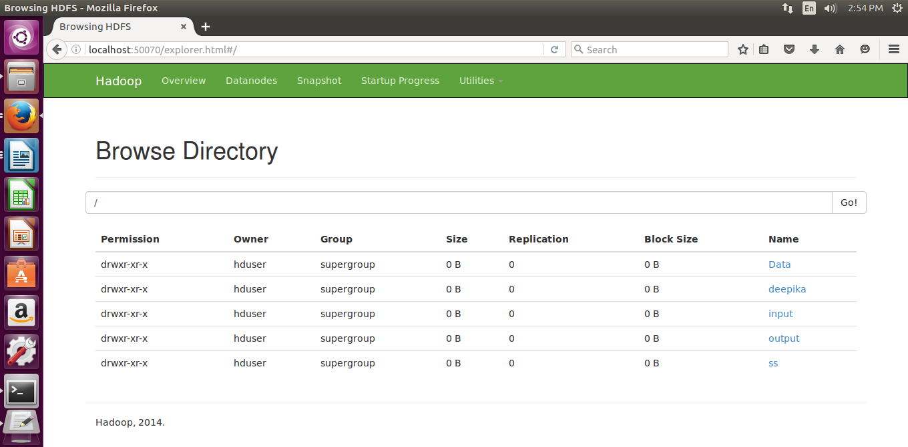

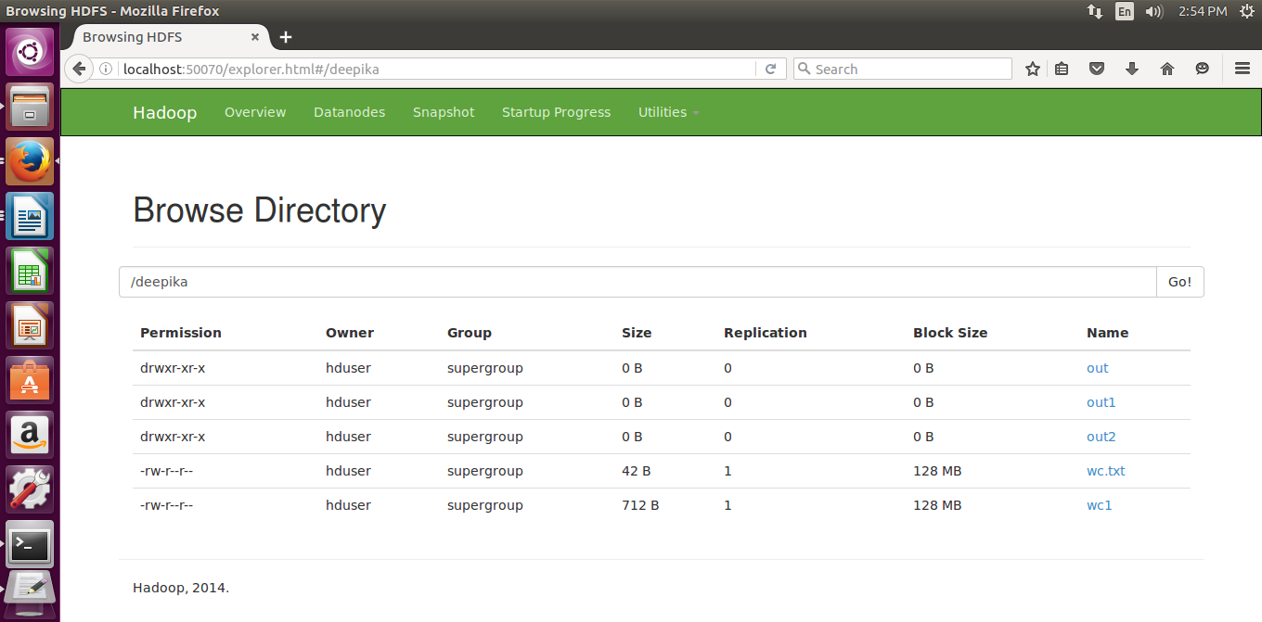

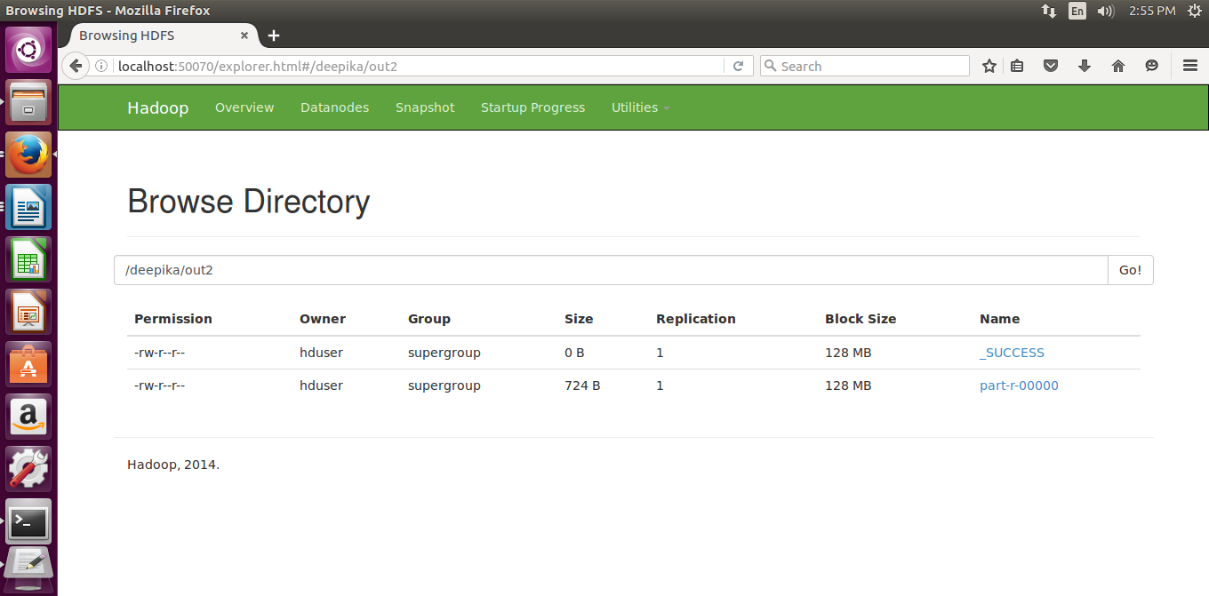

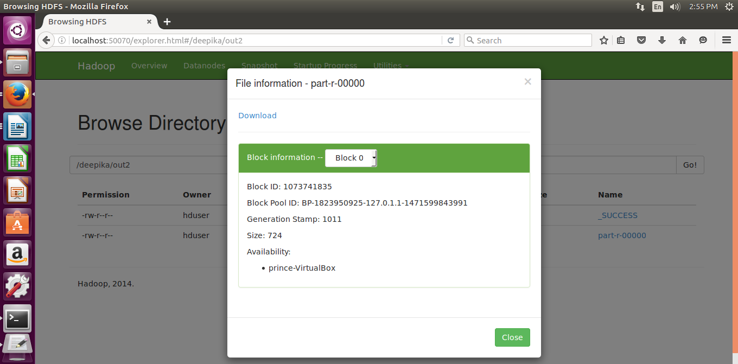

/mit/wordcount/input 2

/mit/wordcount/input/input.txt 1

/mit/wordcount/output. 1

/opt/hadoop-2.7.0/input.txt 1

1. 1

2. 1

3. 1

4. 1

5. 1

6. 1

7. 1

8. 1

Create 2

HADOOP_CLASSPATH=${JAVA_HOME}/lib/tools.jar 1

Move 1

Open 1

STEPS: 1

Set 1

The 1

To 2

WordCount 2

WordCount*.class 1

WordCount.java 2

a 2

an 1

and 4

as 2

available 1

be 1

bin/hadoop 3

cf 1

com.sun.tools.javac.Main 1

compile 1

create 1

directory 1

directory. 1

editor 1

execute, 1

export 1

file, 1

files 2

files. 1

for 1

fs 1

hdfs 1

hdfs, 1

i/p 2

in 2

input 1

input.txt,input1.txt 1

input2.txt 1

jar 3

mapreduce 1

other 1

output 1

path 1

program 1

program, 1

repeat 1

result 1

save 1

step 1

system, 1

the 3

these 1

this 1

to 1

two 1

type 1

wc.jar 2

will 1

–put 1

**RESULT :**

Thus hadoop single node cluster is installed and simple wordcount application is executed.